**Case study: Online Real Estate**

**Name: Muthuohmprakaash M**

**Team: 4**

**Case Study Implementation : Develop web Application**

**ABSTRACT**

The Real Estate Web Application is an interactive, effective website designed for the Real Estate Industry. The main objective of this application is to help the Real Estate Company to display unlimited number of property listings on the website. Buyer search for property listings specific to their needs. The search engine not only provides an easy and convenient way to search for listings but also display the entire list of properties in a customized grid format. The buyer can then view the complete specification of each property listing with its features, description. The intention of designing this application is to develop something new, innovative and efficient using technologies like JSP, Java Script, Java Servlet etc. The main emphasis lies in providing a user-friendly operation for Buyer And Seller for effectively showing the desired results

**INTRODUCTION**

There are large numbers of commercial real estate online information service providers offering a suite of commercial properties and services. These online marketplaces have commercial real estate properties for sale and Rent under various categories including Plot, Apartment, House for sale and Rent as well. There purpose it to attract user of Person who buys And the Person Who Sell The Property to select the properties with desired features. buyers to have a look at the available property listings with all its necessary specification and description And the seller to Post The P Details of Which he want to sell. This application is an effort to provide such a web interface with some attractive and innovative using the technologies. Real Estate Web Application is an TOMCAT SERVER enabled website with the JSP controls giving attractive and interactive look to the web pages. buyer specify their requirements to get the correct set of records from the database.

**SYSTEM ANALYSIS**

**EXISTING SYSTEM**

One of the basic problems with the existing systems is the non-interactive environment they provide to the users Most of the applications involved in Real Estate business use some web template to put the content specific to their company and make it communicate with the database to search the listings. These templates simply use basic web controls to do this task making the web page non-interactive.

**Disadvantages**

* The stored information may be lost
* Delay in webpage load

**PROPOSED SYSTEM**

Our proposed scheme is based on the JSP and JavaServlet were Each Module which has separate Registration for the login Purpose In addition to that basic operation is done each module of the project . Secured Connection to the database is made Between the project and the MYSQL Workbench

**Advantages**

* Correctness of the data.
* Buyer and seller can easily add data to the database

**SYSTEM REQUIREMENTS**

**3.2 SOFTWARE REQUIREMENTS:**

* Operating system : Windows7/10.
* Coding Language : JSP/JAVA SERVLET
* Data Base : MYSQL

**REQUIREMENT ANALYSIS:**

**Software Environment**

**JSP :**

JavaServer Pages (JSP) is a Java standard technology that **enables you to write dynamic, data-driven pages for your Java web applications**. JSP is built on top of the Java Servlet specification. The two technologies typically work together, especially in older Java web applications JSP can be thought as an extension to servlet technology because it provides features to easily create user views. JSP Page consists of HTML code and provide option to include java code for dynamic content

**Java Servlet :**

A servlet is a Java programming language class that is used **to extend the capabilities of servers that host applications accessed by means of a request-response programming model**. Although servlets can respond to any type of request, they are commonly used to extend the applications hosted by web servers The advantages of Servlet are as follows: **Better performance**: because it creates a thread for each request, not process. Portability: because it uses Java language

**CSS :**

CSS is the acronym of “**Cascading Style Sheets**”. CSS is a computer language for laying out and structuring web pages (HTML or XML). This language contains coding elements and is composed of these “cascading style sheets” which are equally called CSS files CSS (Cascading Style Sheets) is used **to style and layout web pages** — for example, to alter the font, color, size, and spacing of your content, split it into multiple columns, or add animations and other decorative features

**JDBC :**

In an effort to set an independent database standard API for Java; Sun Microsystems developed Java Database Connectivity, or JDBC. JDBC offers a generic SQL database access mechanism that provides a consistent interface to a variety of RDBMSs. This consistent interface is achieved through the use of “plug-in” database connectivity modules, or drivers. If a database vendor wishes to have JDBC support, he or she must provide the driver for each platform that the database and Java run on.

**MYSQL :**

MySQL is an open source relational database management system. For WordPress sites, that means it **helps you store all your blog posts, users, plugin information, etc**. It stores that information in separate “tables” and connects it with “keys”, which is why it's relational **MySQL can run on very modest hardware and puts very little strain on system resources**; many small users serve up information to their organizations by running MySQL on modest desktop systems. The speed with which it can retrieve information has made it a longstanding favorite of web administrators.

**ARCHITECTURE DIAGRAM**

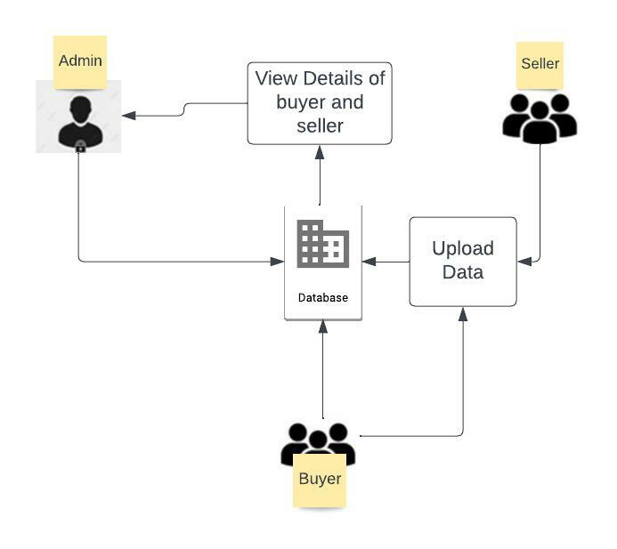

**Fig. 5.1: Architecture diagram**

**MODULES**

**ADMIN :**

* Register the account with the basic information
* login the account with the correct username and password
* After Successful Login, Perform The operation
* Validate the Buyer And Seller Information
* Manage The Deal
* Close The Deal Between buyer and Seller And Remove The website
* Logout

**BUYER:**

* Register the account with the basic information
* login the account with the correct username and password
* After Successful Login, Perform The operation
* Select The property Based On Location
* Book the Date for Site Visit
* Make A Initial Payment For Slot Booking
* Logout

**SELLER :**

* Register the account with the basic information
* Login the account with the correct username and password
* After Successful Login, Perform The operation
* Post The Site Information For Buyer
* Enter The Availability Date
* Finalize The Deal
* Logout

**UML Diagram**

**Use Case Diagram**

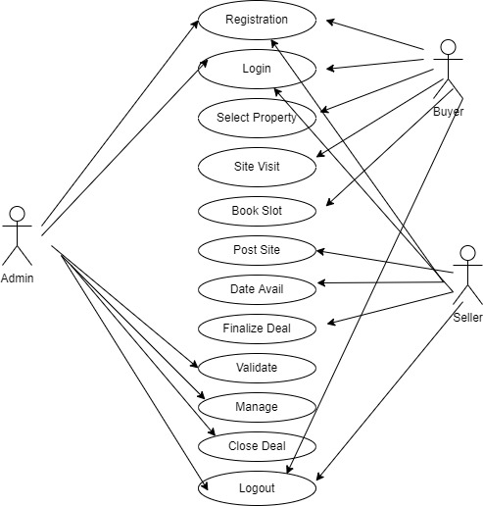

**Use Case Diagram**

**Deployment Diagram**

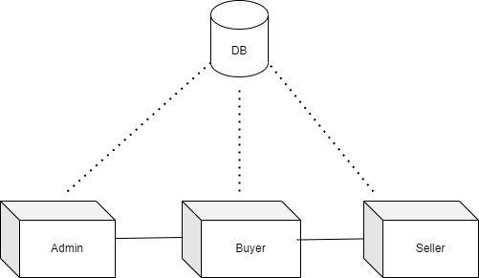

**Deployment Diagram**

**SYSTEM IMPLEMENTATION**

**IMPLEMENTATION PROCEDURE**

Implementation is the stage of the project when the theoretical design is turned out into a working system. Each program is tested individually at the time of development using the data and has verified that this program linked together in the way specified in the programs specification, the computer system and its environment is tested to the satisfaction of the user.

**APACHE TOMCAT SERVER**

Apache Tomcat server: Apache Tomcat is a web container. It **allows the users to run Servlet and JAVA Server Pages that are based on the web-applications**. It can be used as the HTTP server. The performance of the Tomcat server is not as good as the designated web server Apache Tomcat is an **open source application server** that executes Java Servlets, renders and delivers web pages that include JavaServer Page code, and serves Java Enterprise Edition (Java EE) applications. Released in 1998, Tomcat is the most widely used open source Java application server.

**CONCLUSION AND FUTURE ENHANCEMENTS**

**8.1. CONCLUSION**

This Real Estate Web Application is a typical JSP web application using TOMCAT SRVER. It uses a client/server architecture based on the HTTP protocol. It is developed in NETBEANS programming environment. The buyer performs a Selecting for the property listings by putting Location in the search textbox. The business logic tier communicates with the database tier requesting the results of the query sent by it. The results obtained by the database are displayed on the Webpages. Efficiency of the application is improved by the use of web methods that help in separating Application . Efficiency and correctness of the application is evaluated with the help of various test cases.

**8.2. APPLICATION AND FUTURE ENHANCEMENTS**

This project is developed as a project and still gives lot of scope for its extension which could be made to the project if it is going to be developed as commercial product. In doing this, we can get a better architecture design which will improve code efficiency and running performance. Besides, we can build XML web service programming model that enables other applications to consume real estate web services built by us using standard protocol such as HTTP, XML, XSD, SOAP and web services description language (WSDL). This project just deals with the Home page and Search page to search for property listings, more functionality can be added

**APPENDIX - 1**

**NetBeans**

NetBeans IDE is **a free and open source integrated development environment for application development on Windows, Mac, Linux, and Solaris operating systems**. The IDE simplifies the development of web, enterprise, desktop, and mobile applications that use the Java and HTML5 platforms.  NetBeans allows applications to be developed from a set of modular software components called modules

**APPENDIX – 2**

**IMPLEMENTATION CODE**

**AdminLr.jsp**

**<%@ page errorPage="error.jsp" %>**

**<%@ page session = "true" %>**

**<html>**

**<head>**

**<link rel="stylesheet" href="https://maxcdn.bootstrapcdn.com/bootstrap/3.4.1/css/bootstrap.min.css">**

**<script src="https://ajax.googleapis.com/ajax/libs/jquery/3.5.1/jquery.min.js"></script>**

**<script src="https://maxcdn.bootstrapcdn.com/bootstrap/3.4.1/js/bootstrap.min.js"></script>**

**<script src='https://kit.fontawesome.com/a076d05399.js' crossorigin='anonymous'></script>**

**<!-- <a class="navbar-brand" href=""><i class="glyphicon glyphicon-home"></i> Real-Estate</a> -->**

**<style>**

**body{**

**background-image:url("https://images.pexels.com/photos/305831/pexels-photo-305831.jpeg?auto=compress&cs=tinysrgb&w=1600");**

**background-repeat: no-repeat;**

**background-size: 100% 100%;**

**}**

**</style>**

**</head>**

**<body>**

**<nav class="navbar navbar-inverse navbar-fixed-top">**

**<div class="container-fluid">**

**<div class="navbar-header">**

**<!-- <script src='https://kit.fontawesome.com/a076d05399.js' crossorigin='anonymous'></script>**

**-->**

**<a class="navbar-brand" href="index.jsp"><i class="glyphicon glyphicon-home"></i> Real-Estate</a>**

**</div>**

**<ul class="nav navbar-nav">**

**<li ><a href="index.jsp">Home</a></li>**

**<li ><a href="BuyerLR.jsp">Buyer</a></li>**

**<li class="active"><a href="#">Admin</a></li>**

**<li><a href="SellerLR.jsp">Seller</a></li>**

**<!-- <li><a href="EmployeeLogin.jsp">Employee</a></li> -->**

**<%**

**// must provide logout option.**

**%>**

**</ul>**

**</div>**

**</nav>**

**<br><br>**

**<br><br>**

**<div class="container">**

**<div class="d-flex justify-content-center align-items-center ">**

**<div class="row">**

**<div class="col-sm-4">**

**<h3><b>Admin REGISTER/LOGIN</b></h3>**

**<hr>**

**</div>**

**</div>**

**<div class="row">**

**<div class="col-sm-3">**

**<button type="button" onclick="location.href='registration.jsp'" class="btn btn-primary btn-lg btn-block">NEW USER </button>**

**<br> <br>**

**<button type="button" onclick="location.href='admin.jsp'" class="btn btn-primary btn-lg btn-block">EXISTING USER</button>**

**</div>**

**</div>**

**</div>**

**</div>**

**</body>**

**</html>**

**BuyerLr.jsp**

<!-- <%@ page errorPage="error.jsp" %> -->

<%@ page session = "true" %>

<html>

<head>

<link rel="stylesheet" href="https://maxcdn.bootstrapcdn.com/bootstrap/3.4.1/css/bootstrap.min.css">

<script src="https://ajax.googleapis.com/ajax/libs/jquery/3.5.1/jquery.min.js"></script>

<script src="https://maxcdn.bootstrapcdn.com/bootstrap/3.4.1/js/bootstrap.min.js"></script>

<script src='https://kit.fontawesome.com/a076d05399.js' crossorigin='anonymous'></script>

<!-- <a class="navbar-brand" href=""><i class="glyphicon glyphicon-home"></i> Real-Estate</a> -->

<style>

body{

background-image:url("https://images.pexels.com/photos/399161/pexels-photo-399161.jpeg?auto=compress&cs=tinysrgb&w=1600");

background-repeat: no-repeat;

background-size: 100% 100%;

}

</style>

</head>

<body>

<nav class="navbar navbar-inverse navbar-fixed-top">

<div class="container-fluid">

<div class="navbar-header">

<!-- <script src='https://kit.fontawesome.com/a076d05399.js' crossorigin='anonymous'></script> -->

<a class="navbar-brand" href="index.jsp"><i class="glyphicon glyphicon-home"></i> Real-Estate</a>

</div>

<ul class="nav navbar-nav">

<li ><a href="index.jsp">Home</a></li>

<li class="active"><a href="#">Buyer</a></li>

<li><a href="AdminLr.jsp">Admin</a></li>

<li><a href="SellerLR.jsp">Seller</a></li>

<!-- <li><a href="EmployeeLogin.jsp">Employee</a></li> -->

<%

// must provide logout option.

%>

</ul>

</div>

</nav>

<br><br>

<br><br>

<div class="container">

<div class="d-flex justify-content-center align-items-center ">

<div class="row">

<div class="col-sm-4">

<h3><b>BUYER REGISTER/LOGIN</b></h3>

<hr>

</div>

</div>

<div class="row">

<div class="col-sm-3">

<button type="button" onclick="location.href='registration.jsp'" class="btn btn-primary btn-lg btn-block">NEW USER </button>

<br> <br>

<button type="button" onclick="location.href='buyer.jsp'" class="btn btn-primary btn-lg btn-block">EXISTING USER</button>

</div>

</div>

</div>

</div>

</body>

</html>

**SellerLR.jsp**

**<%@ page errorPage="error.jsp" %>**

**<%@ page session = "true" %>**

**<html>**

**<head>**

**<link rel="stylesheet" href="https://maxcdn.bootstrapcdn.com/bootstrap/3.4.1/css/bootstrap.min.css">**

**<script src="https://ajax.googleapis.com/ajax/libs/jquery/3.5.1/jquery.min.js"></script>**

**<script src="https://maxcdn.bootstrapcdn.com/bootstrap/3.4.1/js/bootstrap.min.js"></script>**

**<script src='https://kit.fontawesome.com/a076d05399.js' crossorigin='anonymous'></script>**

**<!-- <a class="navbar-brand" href=""><i class="glyphicon glyphicon-home"></i> Real-Estate</a> -->**

**<style>**

**body{**

**background-image:url("https://images.pexels.com/photos/5625008/pexels-photo-5625008.jpeg?auto=compress&cs=tinysrgb&w=1600");**

**background-repeat: no-repeat;**

**background-size: 100% 100%;**

**}**

**</style>**

**</head>**

**<body>**

**<nav class="navbar navbar-inverse navbar-fixed-top">**

**<div class="container-fluid">**

**<div class="navbar-header">**

**<!-- <script src='https://kit.fontawesome.com/a076d05399.js' crossorigin='anonymous'></script>**

**-->**

**<a class="navbar-brand" href="index.jsp"><i class="glyphicon glyphicon-home"></i> Real-Estate</a>**

**</div>**

**<ul class="nav navbar-nav">**

**<li ><a href="index.jsp">Home</a></li>**

**<li ><a href="BuyerLR.jsp">Buyer</a></li>**

**<li><a href="AdminLr.jsp">Admin</a></li>**

**<li class="active"><a href="#">Seller</a></li>**

**<!-- <li><a href="EmployeeLogin.jsp">Employee</a></li> -->**

**<%**

**// must provide logout option.**

**%>**

**</ul>**

**</div>**

**</nav>**

**<br><br>**

**<br><br>**

**<div class="container">**

**<div class="d-flex justify-content-center align-items-center ">**

**<div class="row">**

**<div class="col-sm-4">**

**<h3><b>SELLER REGISTER/LOGIN</b></h3>**

**<hr>**

**</div>**

**</div>**

**<div class="row">**

**<div class="col-sm-3">**

**<button type="button" onclick="location.href='registration.jsp'" class="btn btn-primary btn-lg btn-block">NEW USER </button>**

**<br> <br>**

**<button type="button" onclick="location.href='success.jsp'" class="btn btn-primary btn-lg btn-block">EXISTING USER</button>**

**</div>**

**</div>**

**</div>**

**</div>**

**</body>**

**</html>**

**Admin.jsp**

**<%@page contentType="text/html" pageEncoding="UTF-8"%>**

**<!DOCTYPE html>**

**<html>**

**<head>**

**<meta http-equiv="Content-Type" content="text/html; charset=UTF-8">**

**<title>JSP Page</title>**

**<link href="https://cdn.jsdelivr.net/npm/bootstrap@5.1.3/dist/css/bootstrap.min.css" rel="stylesheet" integrity="sha384-1BmE4kWBq78iYhFldvKuhfTAU6auU8tT94WrHftjDbrCEXSU1oBoqyl2QvZ6jIW3" crossorigin="anonymous">**

**<script src="https://cdn.jsdelivr.net/npm/bootstrap@5.1.3/dist/js/bootstrap.bundle.min.js" integrity="sha384-ka7Sk0Gln4gmtz2MlQnikT1wXgYsOg+OMhuP+IlRH9sENBO0LRn5q+8nbTov4+1p" crossorigin="anonymous"></script>**

**<style>**

**html,**

**body {**

**height: 100%;**

**}**

**body {**

**display: flex;**

**align-items: center;**

**padding-top: 40px;**

**padding-bottom: 40px;**

**background-color: #f5f5f5;**

**background-image:url("https://media.istockphoto.com/photos/businessman-or-accountant-holds-a-pen-and-presses-a-calculator-to-picture-id1352373878?b=1&k=20&m=1352373878&s=612x612&w=0&h=8IvMSb4DlNdXzdL2xV8Tnm2v_odxryprXMLzvV44L20=");**

**background-repeat: no-repeat;**

**background-size: 100% 100%;**

**}**

**.form-signin {**

**width: 100%;**

**max-width: 330px;**

**padding: 15px;**

**margin: auto;**

**}**

**.form-signin .checkbox {**

**font-weight: 400;**

**}**

**.form-signin .form-floating:focus-within {**

**z-index: 2;**

**}**

**.form-signin input[type="email"] {**

**margin-bottom: -1px;**

**border-bottom-right-radius: 0;**

**border-bottom-left-radius: 0;**

**}**

**.form-signin input[type="password"] {**

**margin-bottom: 10px;**

**border-top-left-radius: 0;**

**border-top-right-radius: 0;**

**}**

**.marquee1{**

**width: 100%;**

**}**

**</style>**

**</head>**

**<body class="text-center">**

**<main class="form-signin">**

**<form action="adminverify " method ="get">**

**<h3><b> Admin Login</b></h3>**

**<div class="form-floating">**

**<input type="text" class="form-control" id="floating input" name="ename">**

**<label for ="floating input" > Enter email/contactnumber:</label>**

**</div>**

**<div class="form-floating">**

**<input type="password" class="form-control" id="floating input" name="ePassword">**

**<label for ="floating input" > Enter Password:</label>**

**</div><!-- comment -->**

**<button class="w-100 btn btn-lg btn-primary" type="submit" >Sign-in**

**</button><!-- comment -->**

**</form>**

**<br>**

**<div class="marquee1">**

**<marquee bgcolor="orange";><b>According to the survey conducted by the India Brand Equity Foundation in 2016, the demand for residential properties has increased due to growing urbanization and increasing household income.</b></marquee>**

**</div>**

**</main>**

**</body>**

**</html>**

**Admincomplete.jsp**

**<%@page contentType="text/html" pageEncoding="UTF-8"%>**

**<!DOCTYPE html>**

**<html>**

**<head>**

**<meta http-equiv="Content-Type" content="text/html; charset=UTF-8">**

**<title>JSP Page</title>**

**<link href="https://cdn.jsdelivr.net/npm/bootstrap@5.1.3/dist/css/bootstrap.min.css" rel="stylesheet" integrity="sha384-1BmE4kWBq78iYhFldvKuhfTAU6auU8tT94WrHftjDbrCEXSU1oBoqyl2QvZ6jIW3" crossorigin="anonymous">**

**<script src="https://cdn.jsdelivr.net/npm/bootstrap@5.1.3/dist/js/bootstrap.bundle.min.js" integrity="sha384-ka7Sk0Gln4gmtz2MlQnikT1wXgYsOg+OMhuP+IlRH9sENBO0LRn5q+8nbTov4+1p" crossorigin="anonymous"></script>**

**<style>**

**html,**

**body {**

**height: 100%;**

**}**

**body {**

**display: flex;**

**align-items: center;**

**padding-top: 40px;**

**padding-bottom: 40px;**

**background-color: #f5f5f5;**

**background-image:url("https://images.pexels.com/photos/1111367/pexels-photo-1111367.jpeg?auto=compress&cs=tinysrgb&w=1600");**

**background-repeat: no-repeat;**

**background-size: 100% 100%;**

**margin-left: 200px;**

**}**

**.form-signin {**

**width: 100%;**

**max-width: 330px;**

**padding: 15px;**

**margin-right: auto;**

**}**

**.form-signin .checkbox {**

**font-weight: 400;**

**}**

**.form-signin .form-floating:focus-within {**

**z-index: 2;**

**}**

**.form-signin input[type="email"] {**

**margin-bottom: -1px;**

**border-bottom-right-radius: 0;**

**border-bottom-left-radius: 0;**

**}**

**.form-signin input[type="password"] {**

**margin-bottom: 10px;**

**border-top-left-radius: 0;**

**border-top-right-radius: 0;**

**}**

**</style>**

**</head>**

**<body class="text-center">**

**<main class="form-signin">**

**<form action="adminlogout " method ="get">**

**<h3>Deal is placed successfully.....</h3><!-- comment -->**

**<!-- <h3>Now you can succesfully logout</h3>-->**

**<button type="button" onclick="location.href='index.jsp'"; class=" btn btn-primary btn-lg btn-block" >Logout**

**</button><!-- comment -->**

**</form>**

**</main>**

**</body>**

**</html>**

**Admindeal.jsp**

**<%@page contentType="text/html" pageEncoding="UTF-8"%>**

**<!DOCTYPE html>**

**<html>**

**<head>**

**<meta http-equiv="Content-Type" content="text/html; charset=UTF-8">**

**<title>JSP Page</title>**

**<link href="https://cdn.jsdelivr.net/npm/bootstrap@5.1.3/dist/css/bootstrap.min.css" rel="stylesheet" integrity="sha384-1BmE4kWBq78iYhFldvKuhfTAU6auU8tT94WrHftjDbrCEXSU1oBoqyl2QvZ6jIW3" crossorigin="anonymous">**

**<script src="https://cdn.jsdelivr.net/npm/bootstrap@5.1.3/dist/js/bootstrap.bundle.min.js" integrity="sha384-ka7Sk0Gln4gmtz2MlQnikT1wXgYsOg+OMhuP+IlRH9sENBO0LRn5q+8nbTov4+1p" crossorigin="anonymous"></script>**

**<style>**

**html,**

**body {**

**height: 100%;**

**}**

**body {**

**display: flex;**

**align-items: center;**

**padding-top: 40px;**

**padding-bottom: 40px;**

**background-color: #f5f5f5;**

**background-image:url("https://images.pexels.com/photos/814544/pexels-photo-814544.jpeg?auto=compress&cs=tinysrgb&w=1600");**

**background-repeat: no-repeat;**

**background-size: 100% 100%;**

**}**

**.form-signin {**

**width: 100%;**

**max-width: 330px;**

**padding: 15px;**

**margin-left: auto;**

**}**

**.form-signin .checkbox {**

**font-weight: 400;**

**}**

**.form-signin .form-floating:focus-within {**

**z-index: 2;**

**}**

**.form-signin input[type="email"] {**

**margin-bottom: -1px;**

**border-bottom-right-radius: 0;**

**border-bottom-left-radius: 0;**

**}**

**.form-signin input[type="password"] {**

**margin-bottom: 10px;**

**border-top-left-radius: 0;**

**border-top-right-radius: 0;**

**}**

**</style>**

**</head>**

**<body class="text-center">**

**<h1 style="color: whitesmoke">Here comes your Final Deal---></h1>**

**<main class="form-signin">**

**<form action="admindeal " method ="get">**

**<div class="form-floating">**

**<input type="text" class="form-control" id="floating input" name="sname">**

**<label for ="floating input" > Enter seller name:</label>**

**</div>**

**<div class="form-floating">**

**<input type="text" class="form-control" id="floating input" name="snumber">**

**<label for ="floating input" > Enter seller contact number:</label>**

**</div><!-- comment -->**

**<div class="form-floating">**

**<input type="text" class="form-control" id="floating input" name="slocation">**

**<label for ="floating input" > Enter buyer name:</label>**

**</div>**

**<div class="form-floating">**

**<input type="text" class="form-control" id="floating input" name="slocation">**

**<label for ="floating input" > Enter buyer contactnumber:</label>**

**</div>**

**<div class="form-floating">**

**<input type="text" class="form-control" id="floating input" name="slocation">**

**<label for ="floating input" > Date of deal:</label>**

**</div>**

**<button class="w-100 btn btn-lg btn-primary" type="submit" >Submit**

**</button><!-- comment -->**

**</form>**

**</main>**

**</body>**

**</html>**

**Adminverify.jsp**

**<%@page contentType="text/html" pageEncoding="UTF-8"%>**

**<%@ taglib uri="http://java.sun.com/jsp/jstl/core" prefix = "c"%>**

**<%@ taglib uri="http://java.sun.com/jsp/jstl/functions" prefix = "fn"%>**

**<%@ taglib uri="http://java.sun.com/jsp/jstl/sql" prefix = "sql"%>**

**<%@ taglib prefix="c" uri="http://java.sun.com/jsp/jstl/core" %>**

**<html>**

**<head>**

**<meta http-equiv="Content-Type" content="text/html; charset=UTF-8">**

**<title>JSP Page</title>**

**<link rel="stylesheet" href="https://cdn.jsdelivr.net/npm/bootstrap@4.0.0/dist/css/bootstrap.min.css" integrity="sha384-Gn5384xqQ1aoWXA+058RXPxPg6fy4IWvTNh0E263XmFcJlSAwiGgFAW/dAiS6JXm" crossorigin="anonymous">**

**<style>**

**body{**

**background-image:url("https://images.pexels.com/photos/1420709/pexels-photo-1420709.jpeg?auto=compress&cs=tinysrgb&w=1600");**

**background-repeat: no-repeat;**

**background-size: 100% 100%;**

**}**

**</style>**

**</head>**

**<body>**

**<div class="container">**

**<h1 style="color:blue" >seller details :</h1>**

**<hr>**

**<sql:setDataSource driver="com.mysql.cj.jdbc.Driver"**

**url = "jdbc:mysql://localhost:3306/realestateweb"**

**user = "root" password = "root" var ="ds"></sql:setDataSource>**

**<sql:query dataSource = "${ds}" var = "rs">**

**SELECT * from seller;**

**</sql:query>**

**<table class ="table">**

**<tr>**

**<td style="color:red"><b>Seller Name</b></td>**

**<td style="color:red"><b>Contact Number</B></td>**

**<td style="color:red"><b>Location of Site</b></td>**

**<td style="color:red"><b>Property Type</b></td><!-- comment -->**

**<td style="color:red"><b>Budget</b></td>**

**<td style="color:red"><b>Sale/Rent</b></td>**

**</tr>**

**<c:forEach items= "${rs.rows}" var ="row">**

**<tr>**

**<td ><c:out value="${row.name}"/></td>**

**<td ><c:out value="${row.contact}"/></td>**

**<td ><c:out value="${row.locality}"/></td>**

**<td ><c:out value="${row.type}"/></td>**

**<td ><c:out value="${row.amount}"/></td>**

**<td ><c:out value="${row.sale}"/></td>**

**</tr>**

**</c:forEach>**

**</table>**

**<h1 style="color:blue" >Buyer details :</h1>**

**<sql:query dataSource = "${ds}" var = "rs">**

**SELECT * from buyer;**

**</sql:query>**

**<table class ="table">**

**<tr>**

**<td style="color:red"><b>Buyer Name</b></td>**

**<td style="color:red"><b> Contact Number</b></td>**

**<td style="color:red"><b>Location of Site</b></td>**

**<td style="color:red"><b>Property Type</b></td><!-- comment -->**

**<td style="color:red"><b>Budget</b></td>**

**<td style="color:red"><b>Sale/Rent</b></td>**

**<td style="color:red"><b>Date of Visit</b></td>**

**</tr>**

**<c:forEach items= "${rs.rows}" var ="row">**

**<tr>**

**<td ><c:out value="${row.name}"/></td>**

**<td ><c:out value="${row.contact}"/></td>**

**<td ><c:out value="${row.location}"/></td>**

**<td ><c:out value="${row.property}"/></td>**

**<td ><c:out value="${row.budget}"/></td>**

**<td ><c:out value="${row.buy_rent}"/></td>**

**<td ><c:out value="${row.date}"/></td>**

**</tr>**

**</c:forEach>**

**</table>**

**<h2>Please verify the details by contacting the seller and Buyer......</h2>**

**<form action="adminbutton " method ="get">**

**<button class="w-100 btn btn-lg btn-primary" type="submit" >Please click here to place the deal**

**</button>**

**</form>**

**</div>**

**</body>**

**</html>**

**Buyer.jsp**

**<%@page contentType="text/html" pageEncoding="UTF-8"%>**

**<!DOCTYPE html>**

**<html>**

**<head>**

**<meta http-equiv="Content-Type" content="text/html; charset=UTF-8">**

**<title>JSP Page</title>**

**<link href="https://cdn.jsdelivr.net/npm/bootstrap@5.1.3/dist/css/bootstrap.min.css" rel="stylesheet" integrity="sha384-1BmE4kWBq78iYhFldvKuhfTAU6auU8tT94WrHftjDbrCEXSU1oBoqyl2QvZ6jIW3" crossorigin="anonymous">**

**<script src="https://cdn.jsdelivr.net/npm/bootstrap@5.1.3/dist/js/bootstrap.bundle.min.js" integrity="sha384-ka7Sk0Gln4gmtz2MlQnikT1wXgYsOg+OMhuP+IlRH9sENBO0LRn5q+8nbTov4+1p" crossorigin="anonymous"></script>**

**<style>**

**html,**

**body {**

**height: 100%;**

**}**

**body {**

**display: flex;**

**align-items: initial;**

**padding-top: 40px;**

**padding-bottom: 40px;**

**background-color: #f5f5f5;**

**background-image:url("https://images.pexels.com/photos/783745/pexels-photo-783745.jpeg?auto=compress&cs=tinysrgb&w=1600");**

**background-repeat: no-repeat;**

**background-size: 100% 100%;**

**}**

**.form-signin {**

**width: 100%;**

**max-width: 330px;**

**padding: 15px;**

**margin: auto;**

**}**

**.form-signin .checkbox {**

**font-weight: 400;**

**}**

**.form-signin .form-floating:focus-within {**

**z-index: 2;**

**}**

**.form-signin input[type="email"] {**

**margin-bottom: -1px;**

**border-bottom-right-radius: 0;**

**border-bottom-left-radius: 0;**

**}**

**.form-signin input[type="password"] {**

**margin-bottom: 10px;**

**border-top-left-radius: 0;**

**border-top-right-radius: 0;**

**}**

**.marquee1{**

**width: 100%;**

**}**

**</style>**

**</head>**

**<body class="text-center">**

**<main class="form-signin">**

**<form action="buyerregister " method ="get">**

**<h3 style="font-family: var"><b>Buyer Login</b></h3>**

**<div class="form-floating">**

**<input type="text" class="form-control" id="floating input" name="ename">**

**<label for ="floating input" > Enter email/contactnumber:</label>**

**</div>**

**<div class="form-floating">**

**<input type="password" class="form-control" id="floating input" name="ePassword">**

**<label for ="floating input" > Enter Password:</label>**

**</div><!-- comment -->**

**<button class="w-100 btn btn-lg btn-primary" type="submit" >Sign-in**

**</button><!-- comment -->**

**<br>**

**<hr>**

**<br>**

**</form>**

**<div class="marquee1">**

**<marquee bgcolor="orange";><b>If you are the kind who follows the business media closely,you would probably be thinking that for the last few months all people have done across india is buy -home,plot,apartment to live in</b></marquee>**

**</div>**

**</main>**

**</body>**

**</html>**

**Buyerdetails.jsp**

**<%--**

**Document : sellerregister**

**Created on : Aug 5, 2022, 5:12:18 PM**

**Author : Sony**

**--%>**

**<%@page contentType="text/html" pageEncoding="UTF-8"%>**

**<!DOCTYPE html>**

**<html>**

**<head>**

**<meta http-equiv="Content-Type" content="text/html; charset=UTF-8">**

**<title>JSP Page</title>**

**<link href="https://cdn.jsdelivr.net/npm/bootstrap@5.1.3/dist/css/bootstrap.min.css" rel="stylesheet" integrity="sha384-1BmE4kWBq78iYhFldvKuhfTAU6auU8tT94WrHftjDbrCEXSU1oBoqyl2QvZ6jIW3" crossorigin="anonymous">**

**<script src="https://cdn.jsdelivr.net/npm/bootstrap@5.1.3/dist/js/bootstrap.bundle.min.js" integrity="sha384-ka7Sk0Gln4gmtz2MlQnikT1wXgYsOg+OMhuP+IlRH9sENBO0LRn5q+8nbTov4+1p" crossorigin="anonymous"></script>**

**<style>**

**html,**

**body {**

**height: 100%;**

**}**

**body {**

**display: flex;**

**align-items: center;**

**padding-top: 40px;**

**padding-bottom: 40px;**

**background-color: #f5f5f5;**

**background-image:url("https://images.pexels.com/photos/1921035/pexels-photo-1921035.jpeg?auto=compress&cs=tinysrgb&w=1600");**

**background-repeat: no-repeat;**

**background-size: 100% 100%;**

**}**

**.form-signin {**

**width: 100%;**

**max-width: 330px;**

**padding: 15px;**

**margin: auto;**

**}**

**.form-signin .checkbox {**

**font-weight: 400;**

**}**

**.form-signin .form-floating:focus-within {**

**z-index: 2;**

**}**

**.form-signin input[type="email"] {**

**margin-bottom: -1px;**

**border-bottom-right-radius: 0;**

**border-bottom-left-radius: 0;**

**}**

**.form-signin input[type="password"] {**

**margin-bottom: 10px;**

**border-top-left-radius: 0;**

**border-top-right-radius: 0;**

**}**

**</style>**

**</head>**

**<body class="text-center">**

**<main class="form-signin">**

**<form action="buyerdetails " method ="get">**

**<h5 style="color: aqua"><b>Login Successful....</b></h5>**

**<div class="form-floating">**

**<input type="text" class="form-control" id="floating input" name="bname">**

**<label for ="floating input" > Enter Name:</label>**

**</div>**

**<div class="form-floating">**

**<input type="text" class="form-control" id="floating input" name="bnumber">**

**<label for ="floating input" > Enter contact number:</label>**

**</div><!-- comment -->**

**<div class="form-floating">**

**<input type="text" class="form-control" id="floating input" name="blocation">**

**<label for ="floating input" > site location looking for:</label>**

**</div>**

**<div class="form-floating">**

**<input type="text" class="form-control" id="floating input" name="btype">**

**<label for ="floating input" > property searching for(apartment/plot/house):</label>**

**</div>**

**<div class="form-floating">**

**<input type="text" class="form-control" id="floating input" name="bcost">**

**<label for ="floating input" > Enter expected budget:</label>**

**</div>**

**<div class="form-floating">**

**<input type="text" class="form-control" id="floating input" name="brent">**

**<label for ="floating input" > Looking for rent or sale:</label>**

**</div>**

**<div class="form-floating">**

**<input type="text" class="form-control" id="floating input" name="bdate">**

**<label for ="floating input" > Date you want to visit:</label>**

**</div>**

**<button class="w-100 btn btn-lg btn-primary" type="submit" >Submit**

**</button><!-- comment -->**

**</form>**

**</main>**

**</body>**

**</html>**

**Buyerlogout.jsp**

**<%--**

**Document : sellerregister**

**Created on : Aug 5, 2022, 5:12:18 PM**

**Author : Sony**

**--%>**

**<%@page contentType="text/html" pageEncoding="UTF-8"%>**

**<!DOCTYPE html>**

**<html>**

**<head>**

**<meta http-equiv="Content-Type" content="text/html; charset=UTF-8">**

**<title>JSP Page</title>**

**<link href="https://cdn.jsdelivr.net/npm/bootstrap@5.1.3/dist/css/bootstrap.min.css" rel="stylesheet" integrity="sha384-1BmE4kWBq78iYhFldvKuhfTAU6auU8tT94WrHftjDbrCEXSU1oBoqyl2QvZ6jIW3" crossorigin="anonymous">**

**<script src="https://cdn.jsdelivr.net/npm/bootstrap@5.1.3/dist/js/bootstrap.bundle.min.js" integrity="sha384-ka7Sk0Gln4gmtz2MlQnikT1wXgYsOg+OMhuP+IlRH9sENBO0LRn5q+8nbTov4+1p" crossorigin="anonymous"></script>**

**<style>**

**html,**

**body {**

**height: 100%;**

**}**

**body {**

**display: flex;**

**align-items: center;**

**padding-top: 40px;**

**padding-bottom: 40px;**

**background-color: #f5f5f5;**

**background-image:url("https://images.pexels.com/photos/1111367/pexels-photo-1111367.jpeg?auto=compress&cs=tinysrgb&w=1600");**

**background-repeat: no-repeat;**

**background-size: 100% 100%;**

**margin-left: 200px;**

**}**

**.form-signin {**

**width: 100%;**

**max-width: 330px;**

**padding: 15px;**

**margin-right: auto;**

**}**

**.form-signin .checkbox {**

**font-weight: 400;**

**}**

**.form-signin .form-floating:focus-within {**

**z-index: 2;**

**}**

**.form-signin input[type="email"] {**

**margin-bottom: -1px;**

**border-bottom-right-radius: 0;**

**border-bottom-left-radius: 0;**

**}**

**.form-signin input[type="password"] {**

**margin-bottom: 10px;**

**border-top-left-radius: 0;**

**border-top-right-radius: 0;**

**}**

**</style>**

**</head>**

**<body class="text-center">**

**<main class="form-signin">**

**<form action="sellerlogout " method ="get">**

**<h3><b>Transaction Successful.... :) </b></h3><!-- comment -->**

**<button type="button" onclick="location.href='index.jsp'"; class=" btn btn-primary btn-lg btn-block" >Logout**

**</button>**

**</form>**

**</main>**

**</body>**

**</html>**

**Buyerotp.jsp**

**<%--**

**Document : sellerregister**

**Created on : Aug 5, 2022, 5:12:18 PM**

**Author : Sony**

**--%>**

**<%@page contentType="text/html" pageEncoding="UTF-8"%>**

**<!DOCTYPE html>**

**<html>**

**<head>**

**<meta http-equiv="Content-Type" content="text/html; charset=UTF-8">**

**<title>JSP Page</title>**

**<link href="https://cdn.jsdelivr.net/npm/bootstrap@5.1.3/dist/css/bootstrap.min.css" rel="stylesheet" integrity="sha384-1BmE4kWBq78iYhFldvKuhfTAU6auU8tT94WrHftjDbrCEXSU1oBoqyl2QvZ6jIW3" crossorigin="anonymous">**

**<script src="https://cdn.jsdelivr.net/npm/bootstrap@5.1.3/dist/js/bootstrap.bundle.min.js" integrity="sha384-ka7Sk0Gln4gmtz2MlQnikT1wXgYsOg+OMhuP+IlRH9sENBO0LRn5q+8nbTov4+1p" crossorigin="anonymous"></script>**

**<style>**

**html,**

**body {**

**height: 100%;**

**}**

**body {**

**display: flex;**

**align-items: center;**

**padding-top: 40px;**

**padding-bottom: 40px;**

**background-color: #f5f5f5;**

**background-image:url("https://images.pexels.com/photos/2988232/pexels-photo-2988232.jpeg?auto=compress&cs=tinysrgb&w=1600");**

**background-repeat: no-repeat;**

**background-size: 100% 100%;**

**}**

**.form-signin {**

**width: 100%;**

**max-width: 330px;**

**padding: 15px;**

**margin: auto;**

**}**

**.form-signin .checkbox {**

**font-weight: 400;**

**}**

**.form-signin .form-floating:focus-within {**

**z-index: 2;**

**}**

**.form-signin input[type="email"] {**

**margin-bottom: -1px;**

**border-bottom-right-radius: 0;**

**border-bottom-left-radius: 0;**

**}**

**.form-signin input[type="password"] {**

**margin-bottom: 10px;**

**border-top-left-radius: 0;**

**border-top-right-radius: 0;**

**}**

**</style>**

**</head>**

**<body class="text-center">**

**<main class="form-signin">**

**<form action="buyerslot " method ="get">**

**<div class="form-floating">**

**<input type="text" class="form-control" id="floating input" name="sname">**

**<label for ="floating input" > Enter OTP:</label>**

**</div>**

**<button class="w-100 btn btn-lg btn-primary" type="submit" >Submit**

**</button><!-- comment -->**

**</form>**

**</main>**

**</body>**

**</html>**

**Buyerpayment.jsp**

**<%--**

**Document : sellerregister**

**Created on : Aug 5, 2022, 5:12:18 PM**

**Author : Sony**

**--%>**

**<%@page contentType="text/html" pageEncoding="UTF-8"%>**

**<!DOCTYPE html>**

**<html>**

**<head>**

**<meta http-equiv="Content-Type" content="text/html; charset=UTF-8">**

**<title>JSP Page</title>**

**<link href="https://cdn.jsdelivr.net/npm/bootstrap@5.1.3/dist/css/bootstrap.min.css" rel="stylesheet" integrity="sha384-1BmE4kWBq78iYhFldvKuhfTAU6auU8tT94WrHftjDbrCEXSU1oBoqyl2QvZ6jIW3" crossorigin="anonymous">**

**<script src="https://cdn.jsdelivr.net/npm/bootstrap@5.1.3/dist/js/bootstrap.bundle.min.js" integrity="sha384-ka7Sk0Gln4gmtz2MlQnikT1wXgYsOg+OMhuP+IlRH9sENBO0LRn5q+8nbTov4+1p" crossorigin="anonymous"></script>**

**<style>**

**html,**

**body {**

**height: 100%;**

**}**

**body {**

**display: flex;**

**align-items: center;**

**padding-top: 40px;**

**padding-bottom: 40px;**

**background-color: #f5f5f5;**

**background-image:url("https://images.pexels.com/photos/164501/pexels-photo-164501.jpeg?auto=compress&cs=tinysrgb&w=1600");**

**background-repeat: no-repeat;**

**background-size: 100% 100%;**

**}**

**.form-signin {**

**width: 100%;**

**max-width: 330px;**

**padding: 15px;**

**margin: auto;**

**}**

**.form-signin .checkbox {**

**font-weight: 400;**

**}**

**.form-signin .form-floating:focus-within {**

**z-index: 2;**

**}**

**.form-signin input[type="email"] {**

**margin-bottom: -1px;**

**border-bottom-right-radius: 0;**

**border-bottom-left-radius: 0;**

**}**

**.form-signin input[type="password"] {**

**margin-bottom: 10px;**

**border-top-left-radius: 0;**

**border-top-right-radius: 0;**

**}**

**</style>**

**</head>**

**<body class="text-center">**

**<!-- <h2 style="color: white">Payment Gateway</h2>-->**

**<main class="form-signin">**

**<form action="buyerotp " method ="get">**

**<h4>Payment Gateway is open....</h4><!-- comment -->**

**<h6>Enter your card Details</h6>**

**<div class="form-floating">**

**<input type="text" class="form-control" id="floating input" name="sname">**

**<label for ="floating input" > Enter card number:</label>**

**</div>**

**<div class="form-floating">**

**<input type="text" class="form-control" id="floating input" name="snumber">**

**<label for ="floating input" > Expiry date:</label>**

**</div><!-- comment -->**

**<div class="form-floating">**

**<input type="text" class="form-control" id="floating input" name="slocation">**

**<label for ="floating input" > Enter CVV:</label>**

**</div>**

**<div class="form-floating">**

**<input type="text" class="form-control" id="floating input" name="slocation">**

**<label for ="floating input" > Enter amount:</label>**

**</div>**

**<h5 style="color:white">Note: minimum amount for slot booking is Rs.1000</h5>**

**<button class="w-100 btn btn-lg btn-primary" type="submit" >Submit**

**</button><!-- comment -->**

**</form>**

**</main>**

**</body>**

**</html>**

**Buyersuccess.jsp**

**<%@page contentType="text/html" pageEncoding="UTF-8"%>**

**<%@ taglib uri="http://java.sun.com/jsp/jstl/core" prefix = "c"%>**

**<%@ taglib uri="http://java.sun.com/jsp/jstl/functions" prefix = "fn"%>**

**<%@ taglib uri="http://java.sun.com/jsp/jstl/sql" prefix = "sql"%>**

**<%@ taglib prefix="c" uri="http://java.sun.com/jsp/jstl/core" %>**

**<html>**

**<head>**

**<meta http-equiv="Content-Type" content="text/html; charset=UTF-8">**

**<title>JSP Page</title>**

**<link rel="stylesheet" href="https://cdn.jsdelivr.net/npm/bootstrap@4.0.0/dist/css/bootstrap.min.css" integrity="sha384-Gn5384xqQ1aoWXA+058RXPxPg6fy4IWvTNh0E263XmFcJlSAwiGgFAW/dAiS6JXm" crossorigin="anonymous">**

**<style>**

**body{**

**background-image:url("https://images.pexels.com/photos/7060811/pexels-photo-7060811.jpeg?auto=compress&cs=tinysrgb&w=1600");**

**background-repeat: no-repeat;**

**background-size: 100% 100%;**

**text-align: center;**

**}**

**</style>**

**</head>**

**<body>**

**<h1 style="color:blueviolet" ><u>seller details :</u></h1>**

**<hr>**

**<sql:setDataSource driver="com.mysql.cj.jdbc.Driver"**

**url = "jdbc:mysql://localhost:3306/realestateweb"**

**user = "root" password = "root" var ="ds"></sql:setDataSource>**

**<sql:query dataSource = "${ds}" var = "rs">**

**SELECT * from seller;**

**</sql:query>**

**<div class="container">**

**<table class ="table">**

**<tr>**

**<td style="color:red"><b>Seller Name</b></td>**

**<td style="color:red"> <b>Contact number</b></td>**

**<td style="color:red"><b>Location of site</b></td>**

**<td style="color:red"><b>property type</b></td><!-- comment -->**

**<td style="color:red"><b>budget</b></td>**

**<td style="color:red"><b>sale/rent</b></td>**

**</tr>**

**<c:forEach items= "${rs.rows}" var ="row">**

**<tr>**

**<td ><c:out value="${row.name}"/></td>**

**<td ><c:out value="${row.contact}"/></td>**

**<td ><c:out value="${row.locality}"/></td>**

**<td ><c:out value="${row.type}"/></td>**

**<td ><c:out value="${row.amount}"/></td>**

**<td ><c:out value="${row.sale}"/></td>**

**</tr>**

**</c:forEach>**

**</table>**

**<hr>**

**<h2 style="color: midnightblue">....Available on that day to reach out with seller and place a deal....</h2>**

**<form action="buyerbutton " method ="get">**

**<button class="btn btn-primary" type="submit";padding="20px"; border-radius="20px" align="centre" > click here to book a slot**

**</button>**

**</div>**

**</form>**

**</body>**

**</html>**

**Index.jsp**

**<%@ page errorPage="error.jsp" %>**

**<html>**

**<head>**

**<link rel="stylesheet" href="https://maxcdn.bootstrapcdn.com/bootstrap/3.4.1/css/bootstrap.min.css">**

**<script src="https://ajax.googleapis.com/ajax/libs/jquery/3.5.1/jquery.min.js"></script>**

**<script src="https://maxcdn.bootstrapcdn.com/bootstrap/3.4.1/js/bootstrap.min.js"></script>**

**<script src='https://kit.fontawesome.com/a076d05399.js' crossorigin='anonymous'></script>**

**<style>**

**body{**

**background-image:url("https://images.pexels.com/photos/4200831/pexels-photo-4200831.jpeg?auto=compress&cs=tinysrgb&w=1600");**

**background-repeat: no-repeat;**

**background-size: 100% 100%;**

**}**

**</style>**

**</head>**

**<body>**

**<nav class="navbar navbar-inverse navbar-fixed-top">**

**<div class="container-fluid">**

**<div class="navbar-header">**

**<a class="navbar-brand" href="#"><i class="glyphicon glyphicon-home"></i> Real-Estate</a>**

**</div>**

**<ul class="nav navbar-nav">**

**<li class="active"><a href="#">Home</a></li>**

**<li><a href="BuyerLR.jsp">Buyer</a></li>**

**<li><a href="AdminLr.jsp">Admin</a></li>**

**<li><a href="SellerLR.jsp">Seller</a></li>**

**<!-- <li><a href="EmployeeLogin.jsp">Employee</a></li> -->**

**<%**

**if(session.getAttribute("buyerId")!=null || session.getAttribute("sellerId")!=null || session.getAttribute("employeeId")!=null || session.getAttribute("agentId")!=null )**

**{**

**%>**

**<li><a href="Logout.jsp">Logout</a></li>**

**<%**

**}**

**%>**

**</ul>**

**</div>**

**</nav>**

**<br><br><br>**

**<marquee >**

**<h2><b>Did you know you can Buy and Sell - plot,home,apartment in the smarter way </b></h2>**

**</marquee>**

**<marquee direction="right">**

**<h2><b> Welcome to online real Estate </b></h2>**

**</marquee>**

**<%**

**response.setHeader("Cache-Control","no-cache,no-store,must-revalidate");**

**response.setHeader("Pragma","no-cache");**

**response.setHeader("Expires","0");**

**%>**

**</body>**

**</html>**

**Registration.jsp**

**<%--**

**Document : registration**

**Created on : Aug 5, 2022, 1:30:05 PM**

**Author : Sony**

**--%>**

**<%@page contentType="text/html" pageEncoding="UTF-8"%>**

**<!DOCTYPE html>**

**<html>**

**<head>**

**<meta http-equiv="Content-Type" content="text/html; charset=UTF-8">**

**<title>JSP Page</title>**

**<link href="https://cdn.jsdelivr.net/npm/bootstrap@5.1.3/dist/css/bootstrap.min.css" rel="stylesheet" integrity="sha384-1BmE4kWBq78iYhFldvKuhfTAU6auU8tT94WrHftjDbrCEXSU1oBoqyl2QvZ6jIW3" crossorigin="anonymous">**

**<script src="https://cdn.jsdelivr.net/npm/bootstrap@5.1.3/dist/js/bootstrap.bundle.min.js" integrity="sha384-ka7Sk0Gln4gmtz2MlQnikT1wXgYsOg+OMhuP+IlRH9sENBO0LRn5q+8nbTov4+1p" crossorigin="anonymous"></script>**

**<style>**

**html,**

**body {**

**height: 100%;**

**}**

**body {**

**display: flex;**

**align-items: center;**

**padding-top: 40px;**

**padding-bottom: 40px;**

**background-color: #f5f5f5;**

**background-image:url("https://images.pexels.com/photos/101808/pexels-photo-101808.jpeg?auto=compress&cs=tinysrgb&w=1600");**

**background-repeat: no-repeat;**

**background-size: 100% 100%;**

**}**

**.form-signin {**

**width: 100%;**

**max-width: 330px;**

**padding: 15px;**

**margin-right: auto;**

**}**

**.form-signin .checkbox {**

**font-weight: 400;**

**}**

**.form-signin .form-floating:focus-within {**

**z-index: 2;**

**}**

**.form-signin input[type="email"] {**

**margin-bottom: -1px;**

**border-bottom-right-radius: 0;**

**border-bottom-left-radius: 0;**

**}**

**.form-signin input[type="password"] {**

**margin-bottom: 10px;**

**border-top-left-radius: 0;**

**border-top-right-radius: 0;**

**}**

**.marquee1{**

**margin-top: auto;**

**text-align: right;**

**padding: 0px;**

**margin-right: 300px;**

**width: 2000px;**

**}**

**</style>**

**</head>**

**<body class="text-center">**

**<main class="form-signin">**

**<form action="register " method ="GET">**

**<h3>Register here</h3>**

**<div class="form-floating">**

**<input type="text" class="form-control" id="floating input" name="uname">**

**<label for ="floating input" > Full name:</label>**

**</div>**

**<div class="form-floating">**

**<input type="email" class="form-control" id="floating input" name="idemail">**

**<label for ="floating input" > Enter Email:</label>**

**</div><!-- comment -->**

**<div class="form-floating">**

**<input type="password" class="form-control" id="floating input" name="Password">**

**<label for ="floating input" > Password:</label>**

**</div><!-- comment -->**

**<div class="form-floating">**

**<input type="tel" class="form-control" id="floating input" name="number">**

**<label for ="floating input" > contact number:</label>**

**</div>**

**<div class="form-floating">**

**<input type="text" class="form-control" id="floating input" name="textname">**

**<label for ="floating input" > Role(seller/buyer/admin):</label>**

**</div>**

**<button class="w-100 btn btn-lg btn-primary" type="submit" >Register**

**</button><!-- comment -->**

**</form>**

**</main>**

**</body>**

**<div class="marquee1">**

**<marquee bgcolor="orange" ;><b>Did you know ALMOST 53% of the total real estate transaction in india is influenced by the internet</b></marquee>**

**</div>**

**</html>**

**Selleravailable.jsp**

**<%--**

**Document : sellerregister**

**Created on : Aug 5, 2022, 5:12:18 PM**

**Author : Sony**

**--%>**

**<%@page contentType="text/html" pageEncoding="UTF-8"%>**

**<!DOCTYPE html>**

**<html>**

**<head>**

**<meta http-equiv="Content-Type" content="text/html; charset=UTF-8">**

**<title>JSP Page</title>**

**<link href="https://cdn.jsdelivr.net/npm/bootstrap@5.1.3/dist/css/bootstrap.min.css" rel="stylesheet" integrity="sha384-1BmE4kWBq78iYhFldvKuhfTAU6auU8tT94WrHftjDbrCEXSU1oBoqyl2QvZ6jIW3" crossorigin="anonymous">**

**<script src="https://cdn.jsdelivr.net/npm/bootstrap@5.1.3/dist/js/bootstrap.bundle.min.js" integrity="sha384-ka7Sk0Gln4gmtz2MlQnikT1wXgYsOg+OMhuP+IlRH9sENBO0LRn5q+8nbTov4+1p" crossorigin="anonymous"></script>**

**<style>**

**html,**

**body {**

**height: 100%;**

**}**

**body {**

**display: flex;**

**align-items: center;**

**padding-top: 40px;**

**padding-bottom: 40px;**

**background-color: #f5f5f5;**

**background-image:url("https://images.pexels.com/photos/3038740/pexels-photo-3038740.jpeg?auto=compress&cs=tinysrgb&w=1600");**

**background-repeat: no-repeat;**

**background-size: 100% 100%;**

**}**

**.form-signin {**

**width: 100%;**

**max-width: 330px;**

**padding: 15px;**

**margin: auto;**

**}**

**.form-signin .checkbox {**

**font-weight: 400;**

**}**

**.form-signin .form-floating:focus-within {**

**z-index: 2;**

**}**

**.form-signin input[type="email"] {**

**margin-bottom: -1px;**

**border-bottom-right-radius: 0;**

**border-bottom-left-radius: 0;**

**}**

**.form-signin input[type="password"] {**

**margin-bottom: 10px;**

**border-top-left-radius: 0;**

**border-top-right-radius: 0;**

**}**

**</style>**

**</head>**

**<body class="text-center">**

**<main class="form-signin">**

**<form action="sellercomplete " method ="get">**

**<div class="form-floating">**

**<input type="text" class="form-control" id="floating input" name="sname">**

**<label for ="floating input" > Enter your date of availability:</label>**

**</div>**

**<button class="w-100 btn btn-lg btn-primary" type="submit" >Submit**

**</button><!-- comment -->**

**</form>**

**</main>**

**</body>**

**</html>**

**Sellerlogout.jsp**

**<%--**

**Document : sellerregister**

**Created on : Aug 5, 2022, 5:12:18 PM**

**Author : Sony**

**--%>**

**<%@page contentType="text/html" pageEncoding="UTF-8"%>**

**<!DOCTYPE html>**

**<html>**

**<head>**

**<meta http-equiv="Content-Type" content="text/html; charset=UTF-8">**

**<title>JSP Page</title>**

**<link href="https://cdn.jsdelivr.net/npm/bootstrap@5.1.3/dist/css/bootstrap.min.css" rel="stylesheet" integrity="sha384-1BmE4kWBq78iYhFldvKuhfTAU6auU8tT94WrHftjDbrCEXSU1oBoqyl2QvZ6jIW3" crossorigin="anonymous">**

**<script src="https://cdn.jsdelivr.net/npm/bootstrap@5.1.3/dist/js/bootstrap.bundle.min.js" integrity="sha384-ka7Sk0Gln4gmtz2MlQnikT1wXgYsOg+OMhuP+IlRH9sENBO0LRn5q+8nbTov4+1p" crossorigin="anonymous"></script>**

**<style>**

**html,**

**body {**

**height: 100%;**

**}**

**body {**

**display: flex;**

**align-items: center;**

**padding-top: 40px;**

**padding-bottom: 40px;**

**background-color: #f5f5f5;**

**background-image:url("https://images.pexels.com/photos/1111367/pexels-photo-1111367.jpeg?auto=compress&cs=tinysrgb&w=1600");**

**background-repeat: no-repeat;**

**background-size: 100% 100%;**

**margin-left: 200px;**

**}**

**.form-signin {**

**width: 100%;**

**max-width: 330px;**

**padding: 15px;**

**margin-right: auto;**

**}**

**.form-signin .checkbox {**

**font-weight: 400;**

**}**

**.form-signin .form-floating:focus-within {**

**z-index: 2;**

**}**

**.form-signin input[type="email"] {**

**margin-bottom: -1px;**

**border-bottom-right-radius: 0;**

**border-bottom-left-radius: 0;**

**}**

**.form-signin input[type="password"] {**

**margin-bottom: 10px;**

**border-top-left-radius: 0;**

**border-top-right-radius: 0;**

**}**

**</style>**

**</head>**

**<body class="text-center">**

**<main class="form-signin">**

**<form action="sellerlogout " method ="get">**

**<h3>Your availability is updated with the buyer...</h3><!-- comment -->**

**<button type="button" onclick="location.href='index.jsp'"; class=" btn btn-primary btn-lg btn-block" >Logout**

**</button><!-- comment -->**

**</form>**

**</main>**

**</body>**

**</html>**

**Sellerpayment.jsp**

**<%--**

**Document : sellerregister**

**Created on : Aug 5, 2022, 5:12:18 PM**

**Author : Sony**

**--%>**

**<%@page contentType="text/html" pageEncoding="UTF-8"%>**

**<!DOCTYPE html>**

**<html>**

**<head>**

**<meta http-equiv="Content-Type" content="text/html; charset=UTF-8">**

**<title>JSP Page</title>**

**<link href="https://cdn.jsdelivr.net/npm/bootstrap@5.1.3/dist/css/bootstrap.min.css" rel="stylesheet" integrity="sha384-1BmE4kWBq78iYhFldvKuhfTAU6auU8tT94WrHftjDbrCEXSU1oBoqyl2QvZ6jIW3" crossorigin="anonymous">**

**<script src="https://cdn.jsdelivr.net/npm/bootstrap@5.1.3/dist/js/bootstrap.bundle.min.js" integrity="sha384-ka7Sk0Gln4gmtz2MlQnikT1wXgYsOg+OMhuP+IlRH9sENBO0LRn5q+8nbTov4+1p" crossorigin="anonymous"></script>**

**<style>**

**html,**

**body {**

**height: 100%;**

**}**

**body {**

**display: flex;**

**align-items: center;**

**padding-top: 40px;**

**padding-bottom: 40px;**

**background-color: #f5f5f5;**

**}**

**.form-signin {**

**width: 100%;**

**max-width: 330px;**

**padding: 15px;**

**margin: auto;**

**}**

**.form-signin .checkbox {**

**font-weight: 400;**

**}**

**.form-signin .form-floating:focus-within {**

**z-index: 2;**

**}**

**.form-signin input[type="email"] {**

**margin-bottom: -1px;**

**border-bottom-right-radius: 0;**

**border-bottom-left-radius: 0;**

**}**

**.form-signin input[type="password"] {**

**margin-bottom: 10px;**

**border-top-left-radius: 0;**

**border-top-right-radius: 0;**

**}**

**</style>**

**</head>**

**<body class="text-center">**

**<h1>welcome to payment:</h1>**

**<main class="form-signin">**

**<form action="sellerotp " method ="get">**

**<div class="form-floating">**

**<input type="text" class="form-control" id="floating input" name="sname">**

**<label for ="floating input" > Enter card number:</label>**

**</div>**

**<div class="form-floating">**

**<input type="text" class="form-control" id="floating input" name="snumber">**

**<label for ="floating input" > Expiry date:</label>**

**</div><!-- comment -->**

**<div class="form-floating">**

**<input type="text" class="form-control" id="floating input" name="slocation">**

**<label for ="floating input" > Enter CVV:</label>**

**</div>**

**<div class="form-floating">**

**<input type="text" class="form-control" id="floating input" name="slocation">**

**<label for ="floating input" > Enter amount:</label>**

**</div>**

**<h3>Note:Amount for slot booking is 1000</h3>**

**<button class="w-100 btn btn-lg btn-primary" type="submit" >Submit**

**</button><!-- comment -->**

**</form>**

**</main>**

**</body>**

**</html>**

**Sellerregister.jsp**

**<%--**

**Document : sellerregister**

**Created on : Aug 5, 2022, 5:12:18 PM**

**Author : Sony**

**--%>**

**<%@page contentType="text/html" pageEncoding="UTF-8"%>**

**<!DOCTYPE html>**

**<html>**

**<head>**

**<meta http-equiv="Content-Type" content="text/html; charset=UTF-8">**

**<title>JSP Page</title>**

**<link href="https://cdn.jsdelivr.net/npm/bootstrap@5.1.3/dist/css/bootstrap.min.css" rel="stylesheet" integrity="sha384-1BmE4kWBq78iYhFldvKuhfTAU6auU8tT94WrHftjDbrCEXSU1oBoqyl2QvZ6jIW3" crossorigin="anonymous">**

**<script src="https://cdn.jsdelivr.net/npm/bootstrap@5.1.3/dist/js/bootstrap.bundle.min.js" integrity="sha384-ka7Sk0Gln4gmtz2MlQnikT1wXgYsOg+OMhuP+IlRH9sENBO0LRn5q+8nbTov4+1p" crossorigin="anonymous"></script>**

**<style>**

**html,**

**body {**

**height: 100%;**

**}**

**body {**

**display: flex;**

**align-items: center;**

**padding-top: 40px;**

**padding-bottom: 40px;**

**background-color: #f5f5f5;**

**background-image:url("https://images.pexels.com/photos/106399/pexels-photo-106399.jpeg?auto=compress&cs=tinysrgb&w=1600");**

**background-repeat: no-repeat;**

**background-size: 100% 100%;**

**}**

**.form-signin {**

**width: 100%;**

**max-width: 330px;**

**padding: 15px;**

**margin-left: auto;**

**}**

**.form-signin .checkbox {**

**font-weight: 400;**

**}**

**.form-signin .form-floating:focus-within {**

**z-index: 2;**

**}**

**.form-signin input[type="email"] {**

**margin-bottom: -1px;**

**border-bottom-right-radius: 0;**

**border-bottom-left-radius: 0;**

**}**

**.form-signin input[type="password"] {**

**margin-bottom: 10px;**

**border-top-left-radius: 0;**

**border-top-right-radius: 0;**

**}**

**</style>**

**</head>**

**<body class="text-center">**

**<main class="form-signin">**

**<form action="sellerdetails " method ="get">**

**<h5 style="color:green">Login successful...</h5>**

**<h3>Enter Your details</h3>**

**<div class="form-floating">**

**<input type="text" class="form-control" id="floating input" name="sname">**

**<label for ="floating input" > Enter Name:</label>**

**</div>**

**<div class="form-floating">**

**<input type="text" class="form-control" id="floating input" name="snumber">**

**<label for ="floating input" > Enter contact number:</label>**

**</div><!-- comment -->**

**<div class="form-floating">**

**<input type="text" class="form-control" id="floating input" name="slocation">**

**<label for ="floating input" > Enter your site location:</label>**

**</div>**

**<div class="form-floating">**

**<input type="text" class="form-control" id="floating input" name="stype">**

**<label for ="floating input" > Enter type of property(apartment/plot/house):</label>**

**</div>**

**<div class="form-floating">**

**<input type="text" class="form-control" id="floating input" name="scost">**

**<label for ="floating input" > Enter cost of the site:</label>**

**</div>**

**<div class="form-floating">**

**<input type="text" class="form-control" id="floating input" name="srent">**

**<label for ="floating input" > Is it available for rent or sale:</label>**

**</div>**

**<button class="w-100 btn btn-lg btn-primary" type="submit" >Submit**

**</button><!-- comment -->**

**</form>**

**</main>**

**</body>**

**</html>**

**Sellesuccess.jsp**

**<%--**

**Document : Employee_Details**

**Created on : Jul 29, 2022, 10:14:06 AM**

**Author : Sony**

**--%>**

**<%@page contentType="text/html" pageEncoding="UTF-8"%>**

**<%@ taglib uri="http://java.sun.com/jsp/jstl/core" prefix = "c"%>**

**<%@ taglib uri="http://java.sun.com/jsp/jstl/functions" prefix = "fn"%>**

**<%@ taglib uri="http://java.sun.com/jsp/jstl/sql" prefix = "sql"%>**

**<%@ taglib prefix="c" uri="http://java.sun.com/jsp/jstl/core" %>**

**<html>**

**<head>**

**<meta http-equiv="Content-Type" content="text/html; charset=UTF-8">**

**<title>JSP Page</title>**

**<link rel="stylesheet" href="https://cdn.jsdelivr.net/npm/bootstrap@4.0.0/dist/css/bootstrap.min.css" integrity="sha384-Gn5384xqQ1aoWXA+058RXPxPg6fy4IWvTNh0E263XmFcJlSAwiGgFAW/dAiS6JXm" crossorigin="anonymous">**

**<style>**

**body{**

**text-align: center;**

**background-image:url("https://images.pexels.com/photos/950241/pexels-photo-950241.jpeg?auto=compress&cs=tinysrgb&w=1600");**

**background-repeat: no-repeat;**

**background-size: 100% 100%;**

**}**

**</style>**

**</head>**

**<body>**

**<div class="container">**

**<h1 style="color:blueviolet" ><u>Buyer details :</u></h1>**

**<hr>**

**<sql:setDataSource driver="com.mysql.cj.jdbc.Driver"**

**url = "jdbc:mysql://localhost:3306/realestateweb"**

**user = "root" password = "root" var ="ds"></sql:setDataSource>**

**<sql:query dataSource = "${ds}" var = "rs">**

**SELECT * from buyer;**

**</sql:query>**

**<table class ="table">**

**<tr>**

**<td style="color:red"><b>Buyer Name</b></td>**

**<td style="color:red"><b> Contact number</b></td>**

**<td style="color:red"><b>Location of site</b></td>**

**<td style="color:red"><b>property type</b></td><!-- comment -->**

**<td style="color:red"><b>budget</b></td>**

**<td style="color:red"><b>sale/rent</b></td>**

**<td style="color:red"><b>date of visit</b></td>**

**</tr>**

**<c:forEach items= "${rs.rows}" var ="row">**

**<tr>**

**<td ><c:out value="${row.name}"/></td>**

**<td ><c:out value="${row.contact}"/></td>**

**<td ><c:out value="${row.location}"/></td>**

**<td ><c:out value="${row.property}"/></td>**

**<td ><c:out value="${row.budget}"/></td>**

**<td ><c:out value="${row.buy_rent}"/></td>**

**<td ><c:out value="${row.date}"/></td>**

**</tr>**

**</c:forEach>**

**</table>**

**<hr>**

**<h2>Please be available on that day to reach out with buyer</h2>**

**<form action="sellerbutton " method ="get">**

**<button class="btn btn-primary" type="submit" > click here**

**</button>**

**</form>**

**</div>**

**</body>**

**</html>**

**Success.jsp**

**<%--**

**Document : success**

**Created on : Aug 5, 2022, 2:48:21 PM**

**Author : Sony**

**--%>**

**<%@page contentType="text/html" pageEncoding="UTF-8"%>**

**<!DOCTYPE html>**

**<html>**

**<head>**

**<meta http-equiv="Content-Type" content="text/html; charset=UTF-8">**

**<title>JSP Page</title>**

**<link href="https://cdn.jsdelivr.net/npm/bootstrap@5.1.3/dist/css/bootstrap.min.css" rel="stylesheet" integrity="sha384-1BmE4kWBq78iYhFldvKuhfTAU6auU8tT94WrHftjDbrCEXSU1oBoqyl2QvZ6jIW3" crossorigin="anonymous">**

**<script src="https://cdn.jsdelivr.net/npm/bootstrap@5.1.3/dist/js/bootstrap.bundle.min.js" integrity="sha384-ka7Sk0Gln4gmtz2MlQnikT1wXgYsOg+OMhuP+IlRH9sENBO0LRn5q+8nbTov4+1p" crossorigin="anonymous"></script>**

**<style>**

**html,**

**body {**

**height: 100%;**

**}**

**body {**

**display: flex;**

**align-items: center;**

**padding-top: 40px;**

**padding-bottom: 40px;**

**background-color: #f5f5f5;**

**background-image:url("https://images.pexels.com/photos/1370704/pexels-photo-1370704.jpeg?auto=compress&cs=tinysrgb&w=1600");**

**background-repeat: no-repeat;**

**background-size: 100% 100%;**

**}**

**.form-signin {**

**width: 100%;**

**max-width: 330px;**

**padding: 15px;**

**margin: auto;**

**}**

**.form-signin .checkbox {**

**font-weight: 400;**

**}**

**.form-signin .form-floating:focus-within {**

**z-index: 2;**

**}**

**.form-signin input[type="email"] {**

**margin-bottom: -1px;**

**border-bottom-right-radius: 0;**

**border-bottom-left-radius: 0;**

**}**

**.form-signin input[type="password"] {**

**margin-bottom: 10px;**

**border-top-left-radius: 0;**

**border-top-right-radius: 0;**

**}**

**.marquee1{**

**width: 100%;**

**}**

**</style>**

**</head>**

**<body class="text-center">**

**<main class="form-signin">**

**<form action="sellerregister " method ="get">**

**<h3><b>Login</b></h3>**

**<div class="form-floating">**

**<input type="text" class="form-control" id="floating input" name="ename">**

**<label for ="floating input" > Enter email/contactnumber:</label>**

**</div>**

**<div class="form-floating">**

**<input type="password" class="form-control" id="floating input" name="ePassword">**

**<label for ="floating input" > Enter Password:</label>**

**</div><!-- comment -->**

**<button class="w-100 btn btn-lg btn-primary" type="submit" >Sign-in**

**</button><!-- comment -->**

**</form>**

**<br>**

**<div class="marquee1">**

**<marquee bgcolor="orange";><b>By 2024, the real estate market is expected to touch $300 billion USD. But the housing sector of india contributes about 5% to 6% to the nations GDP.</b></marquee>**

**</div>**

**</main>**

**</body>**

**</html>**

**Output screenshot:**

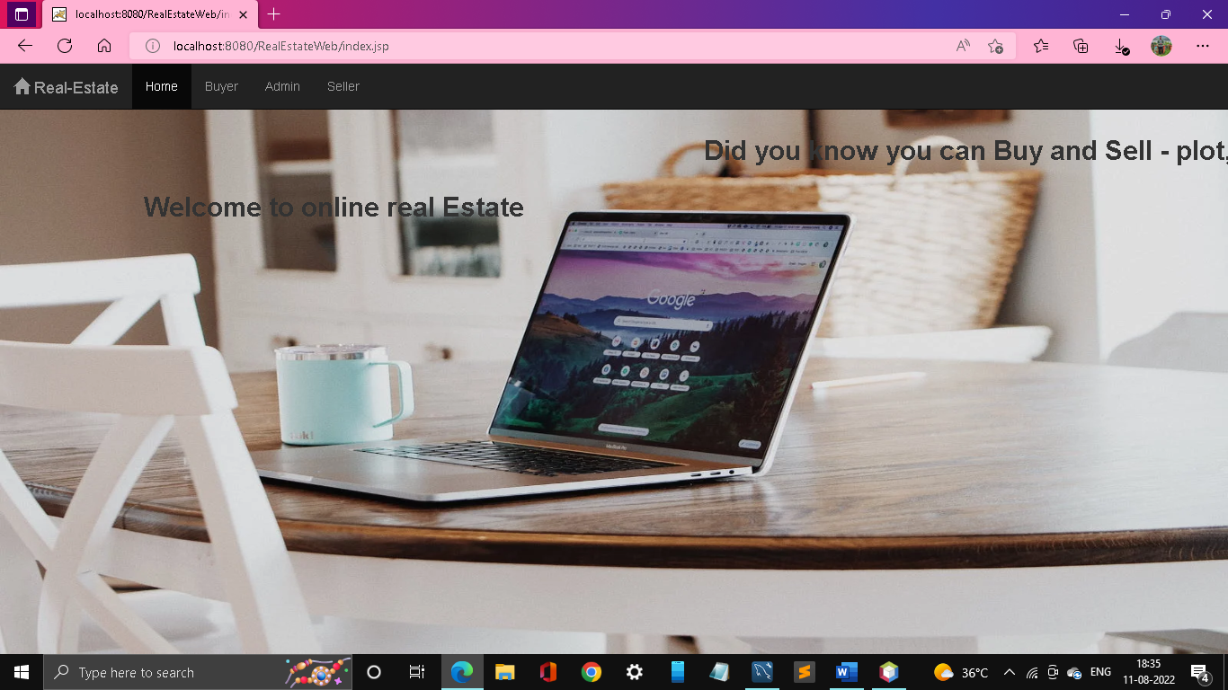

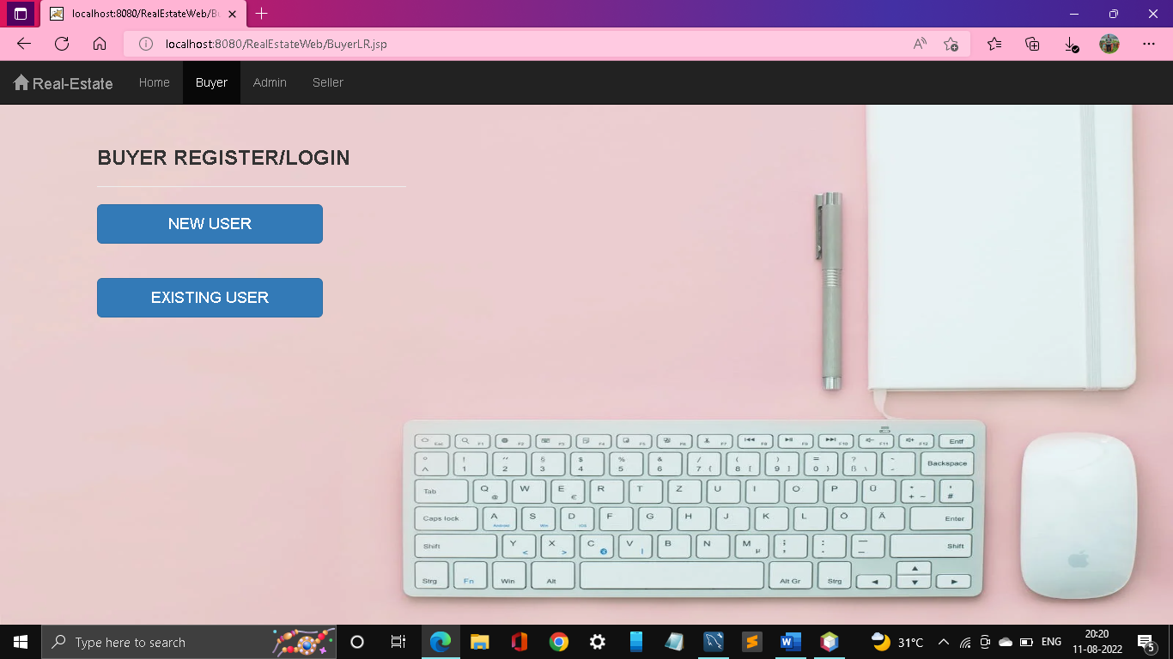

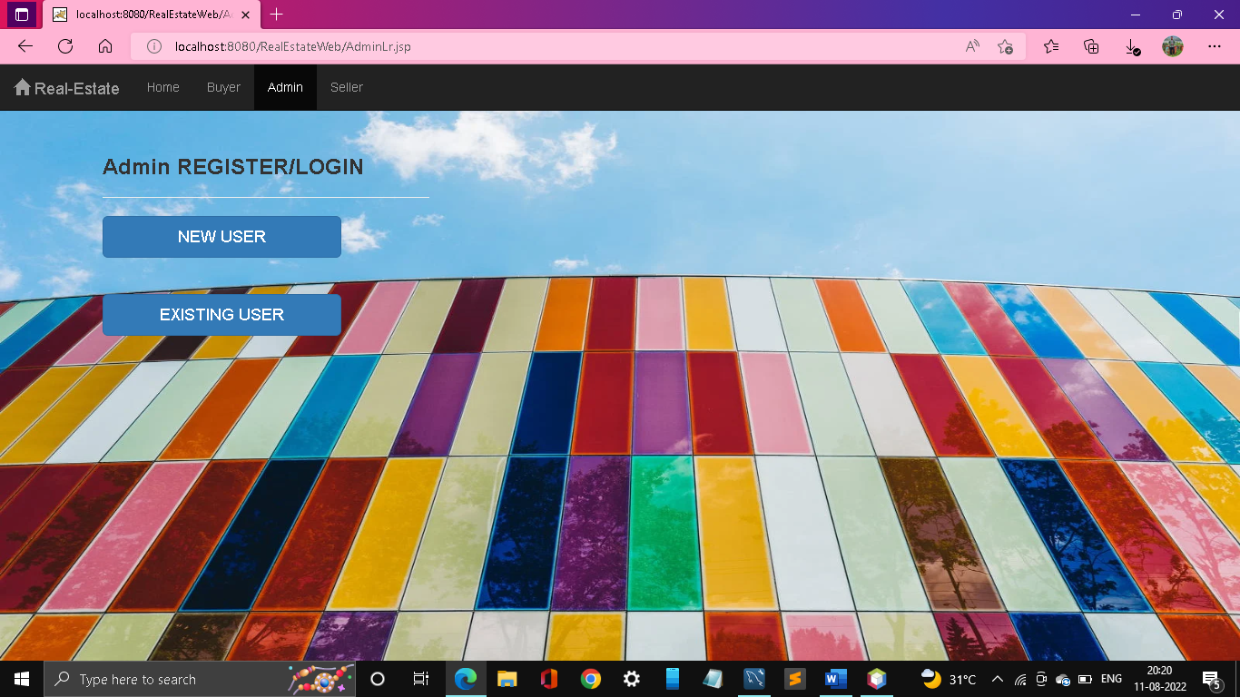

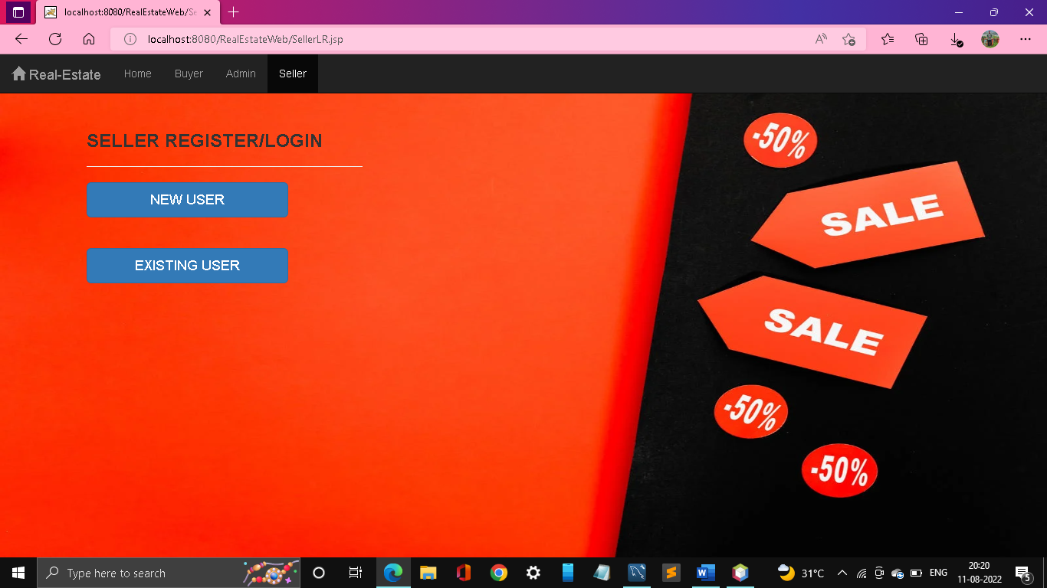

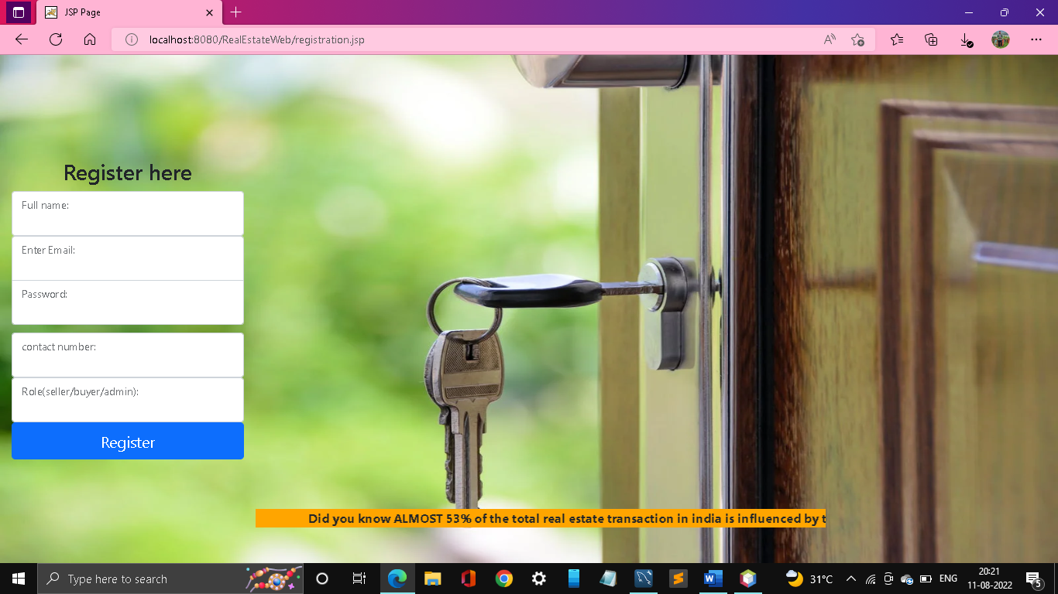

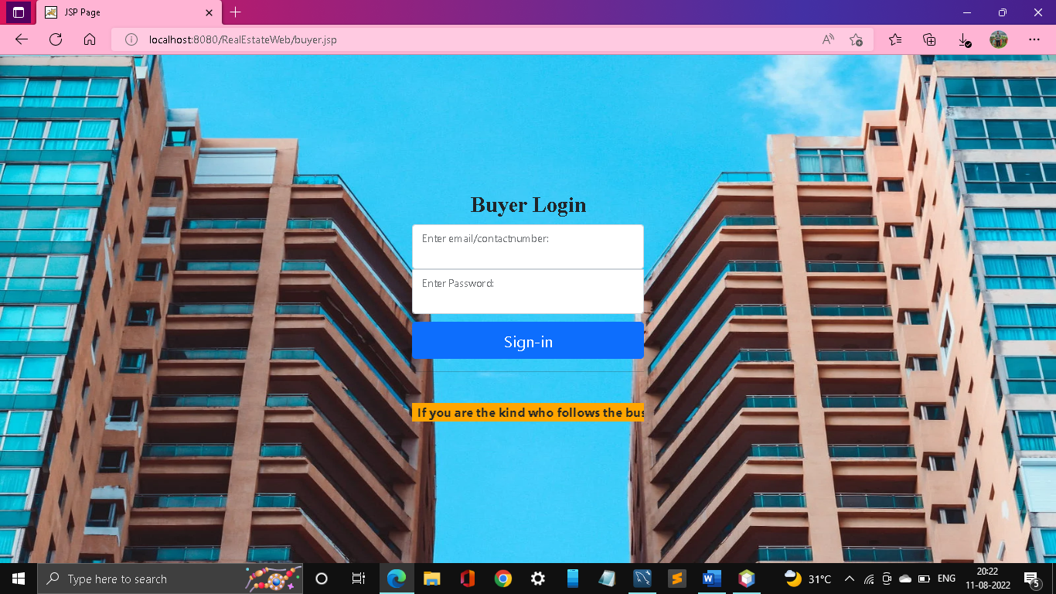

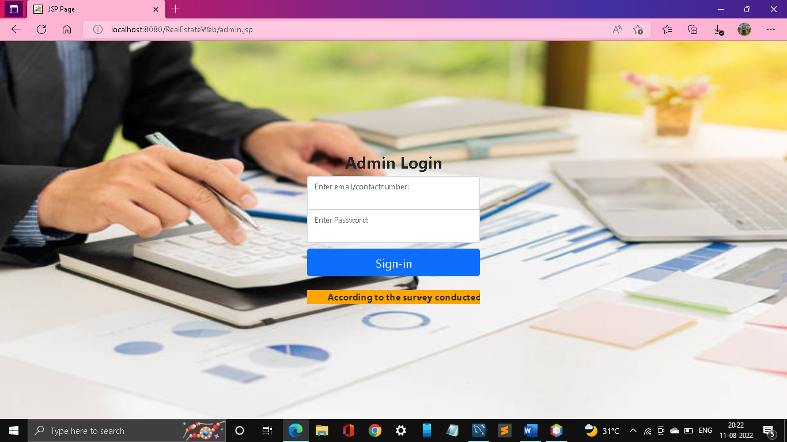

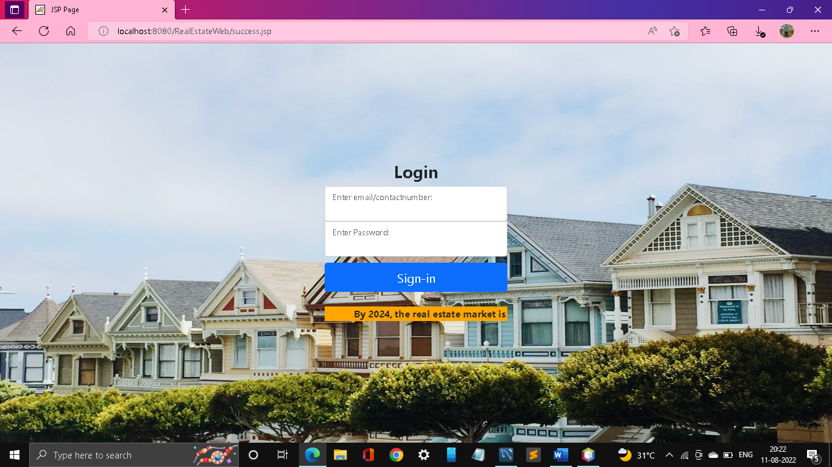

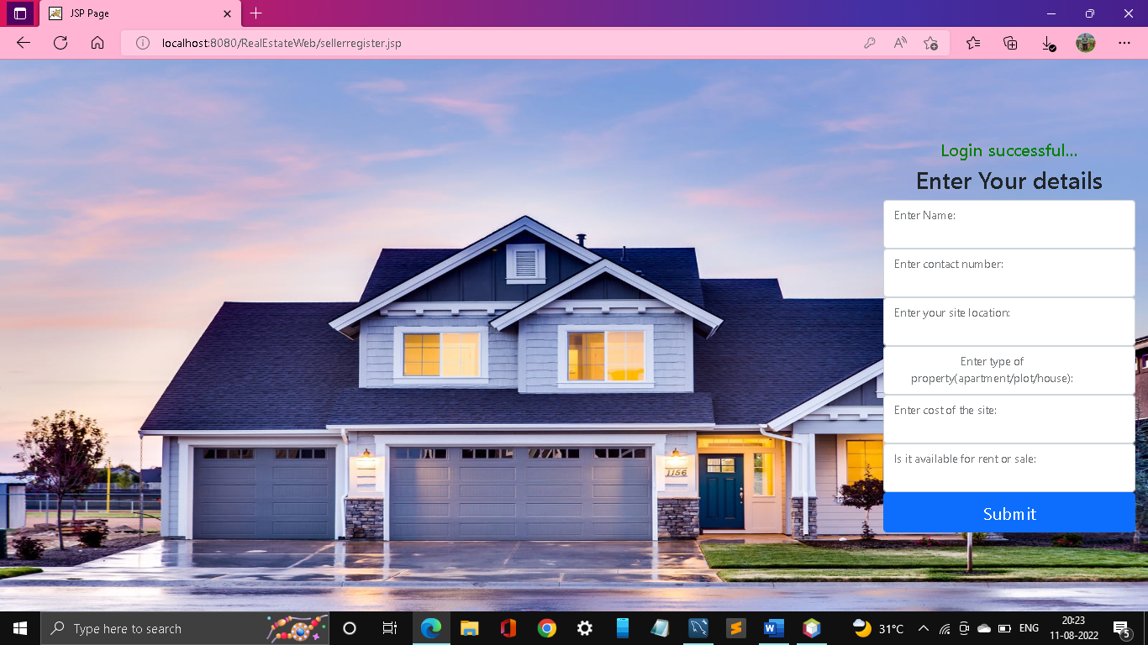

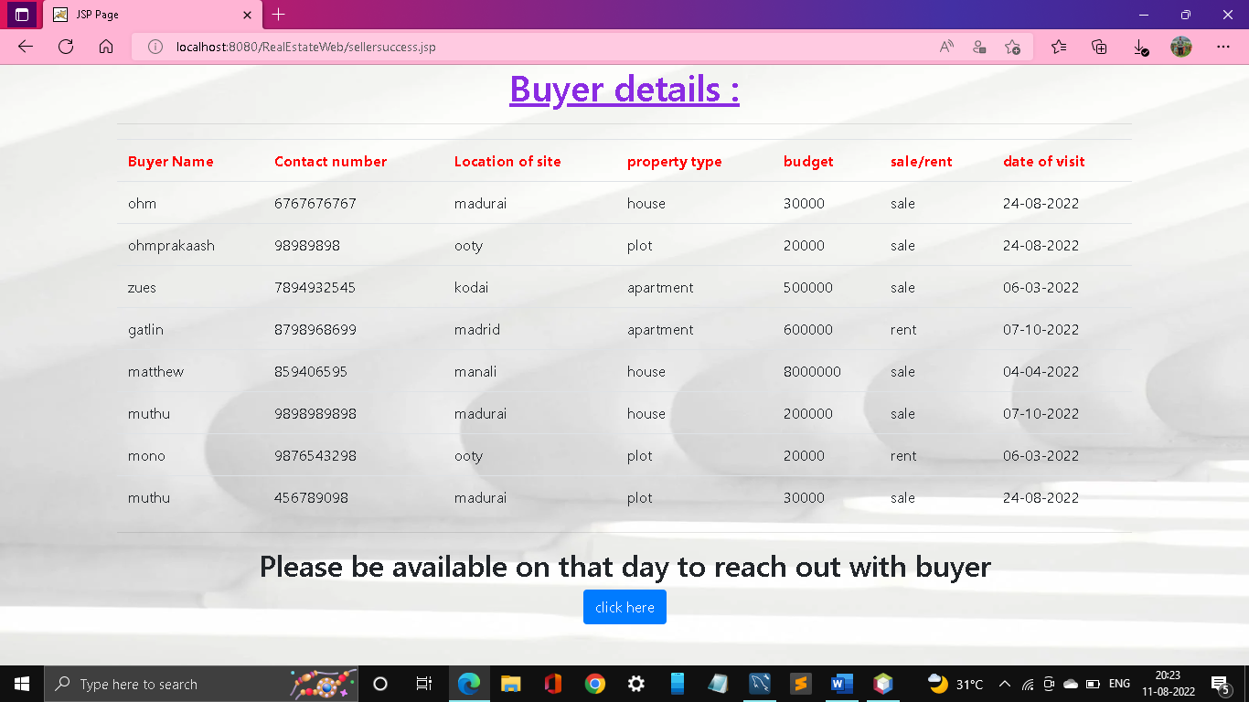

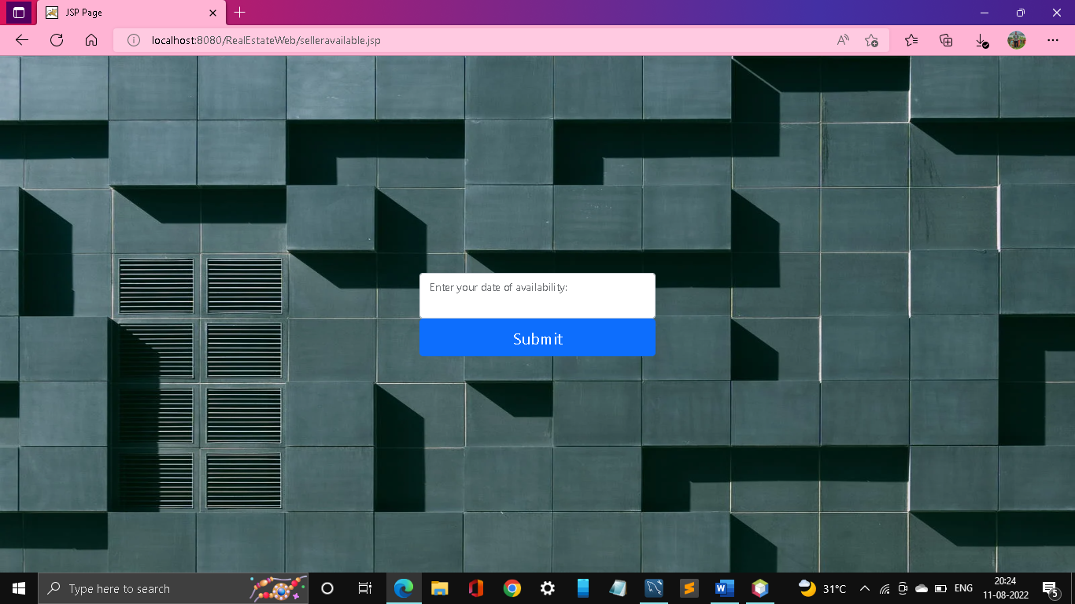

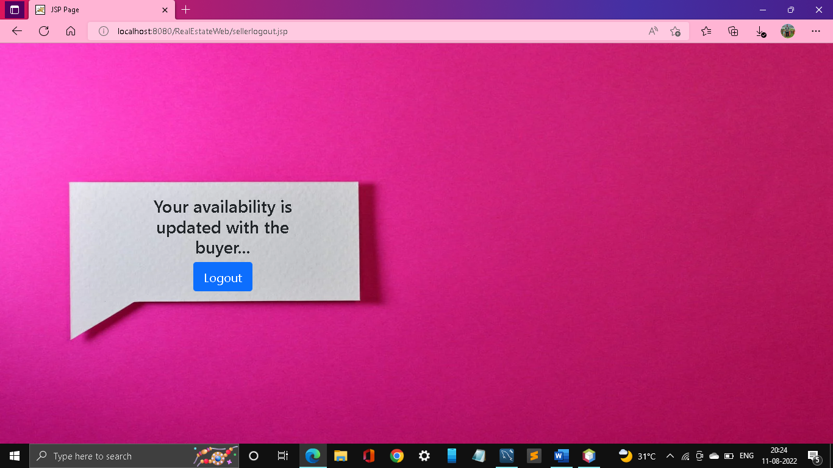

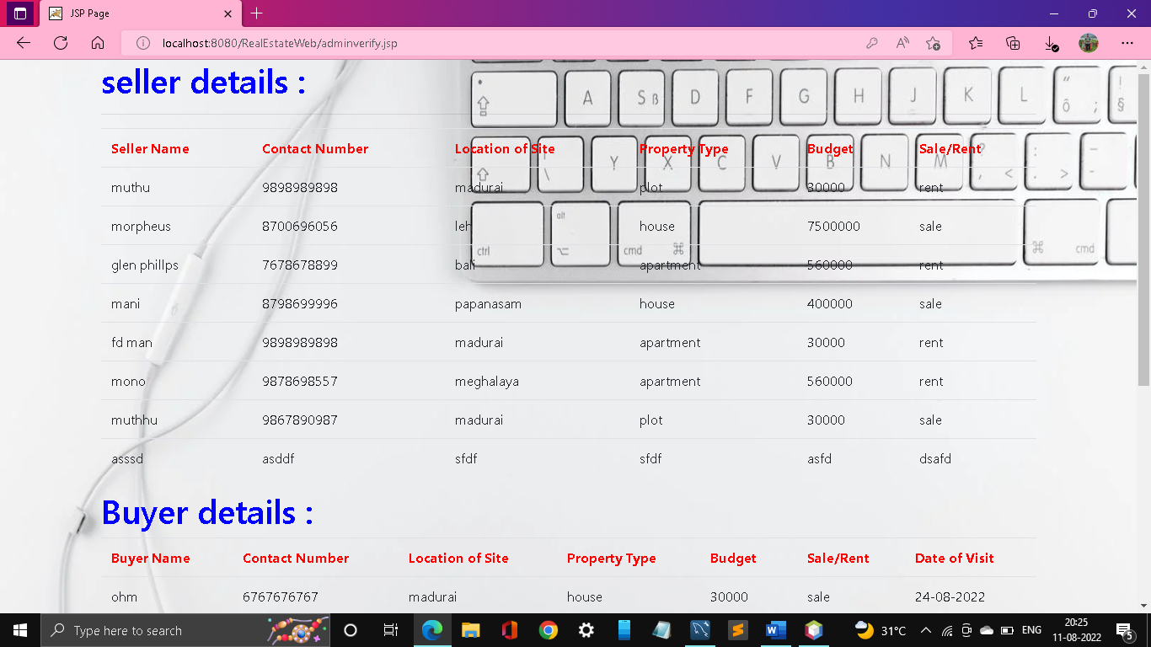

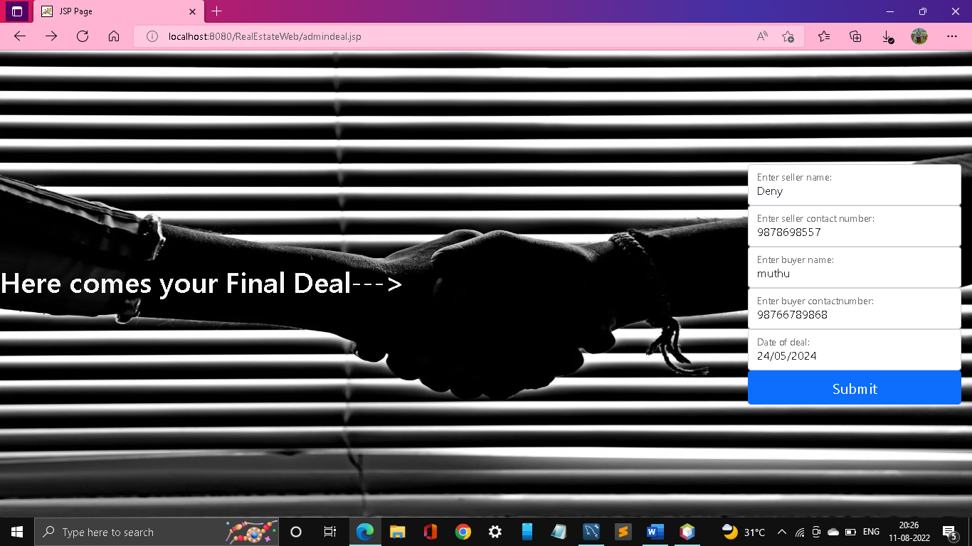

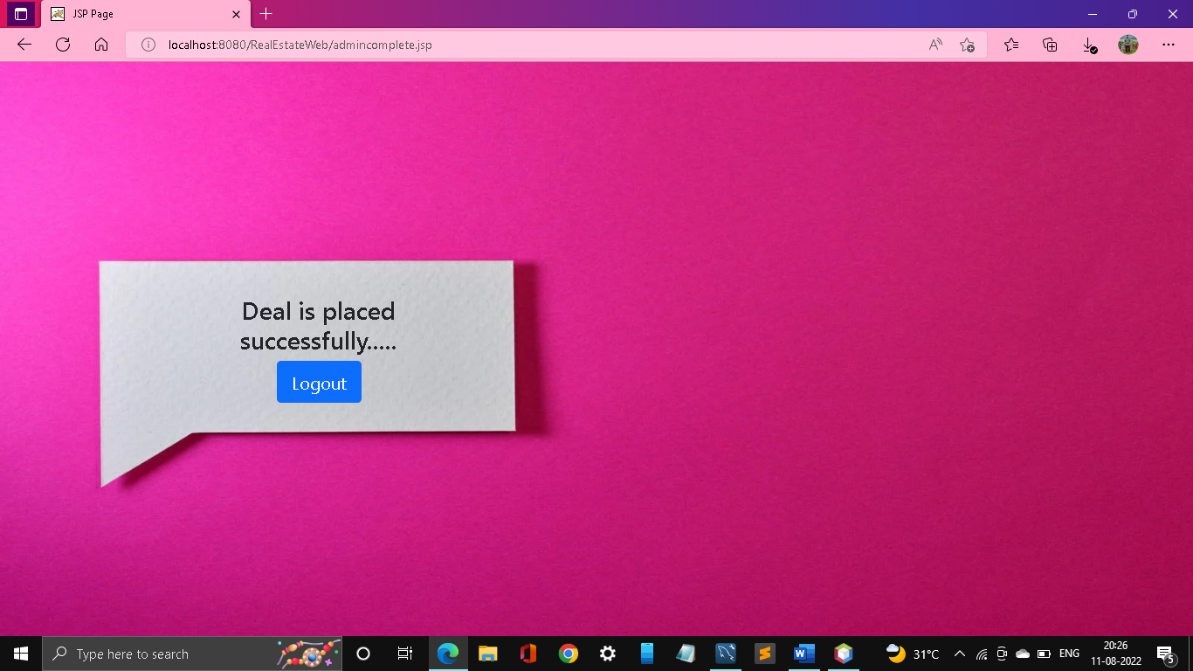

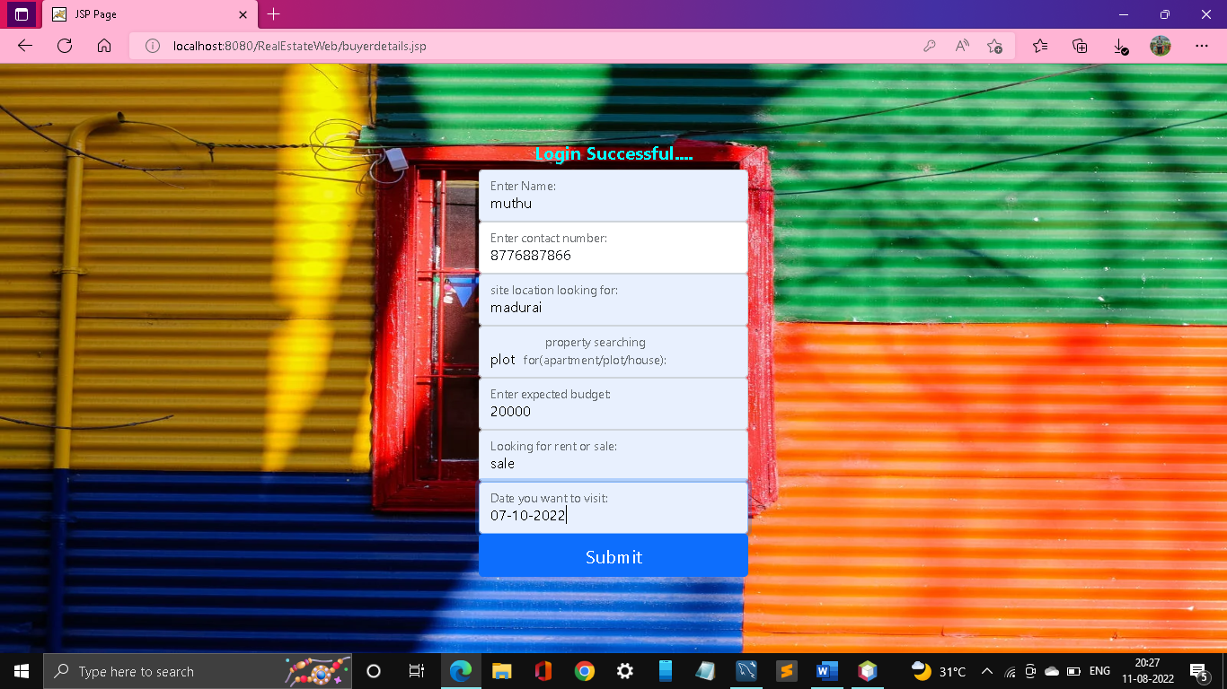

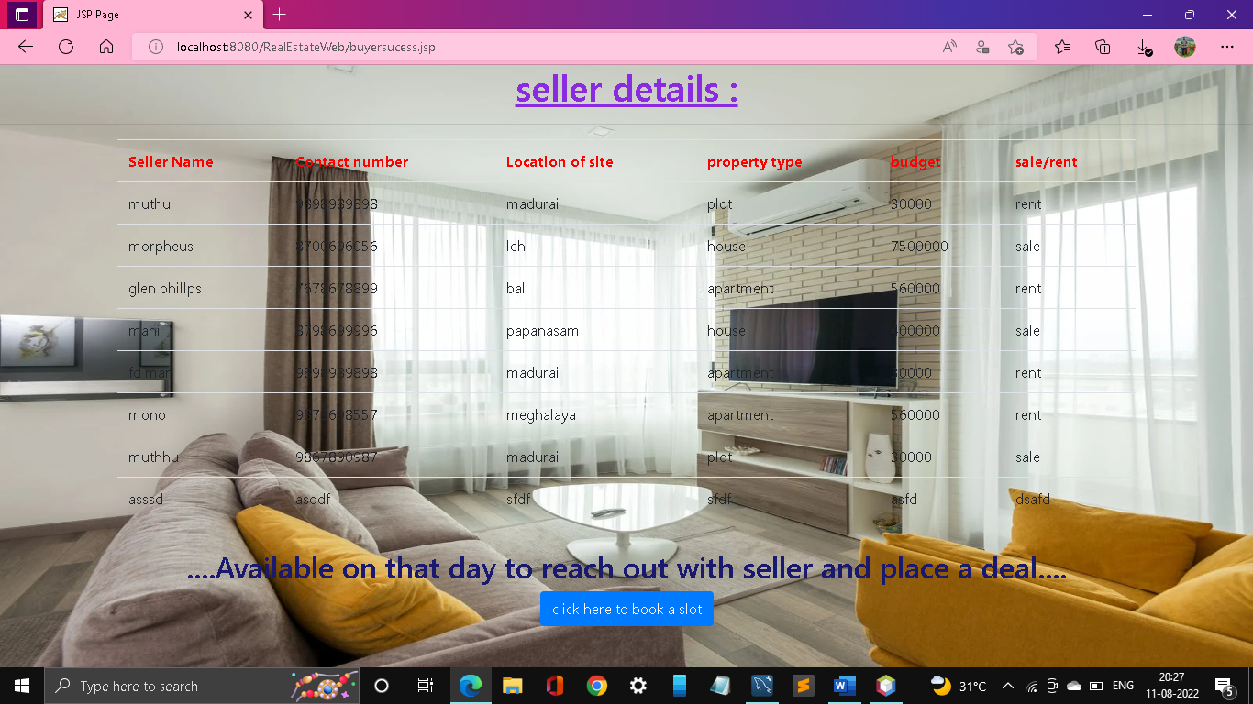

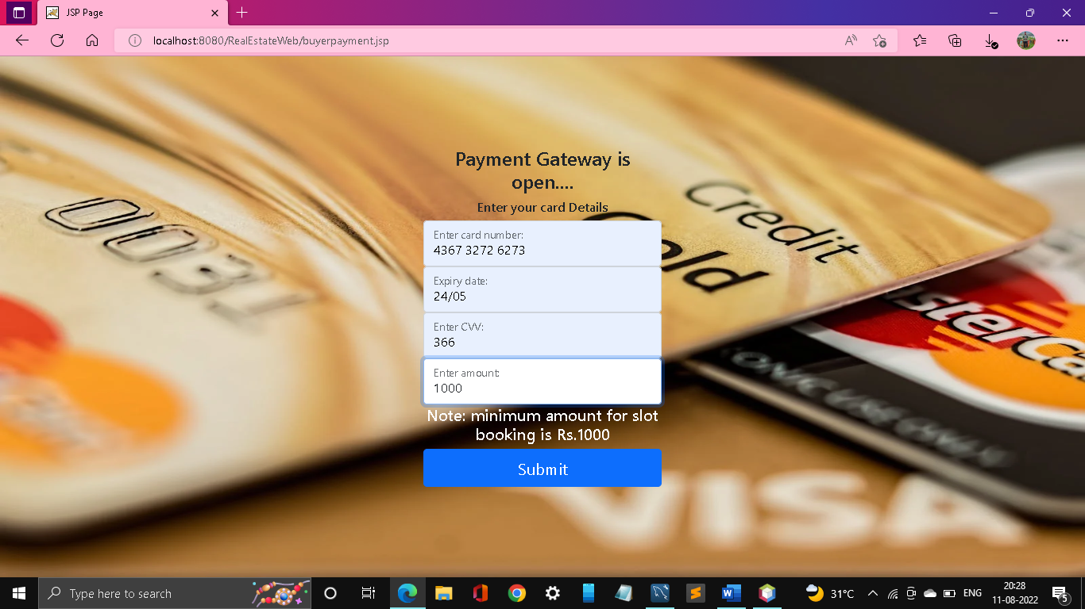

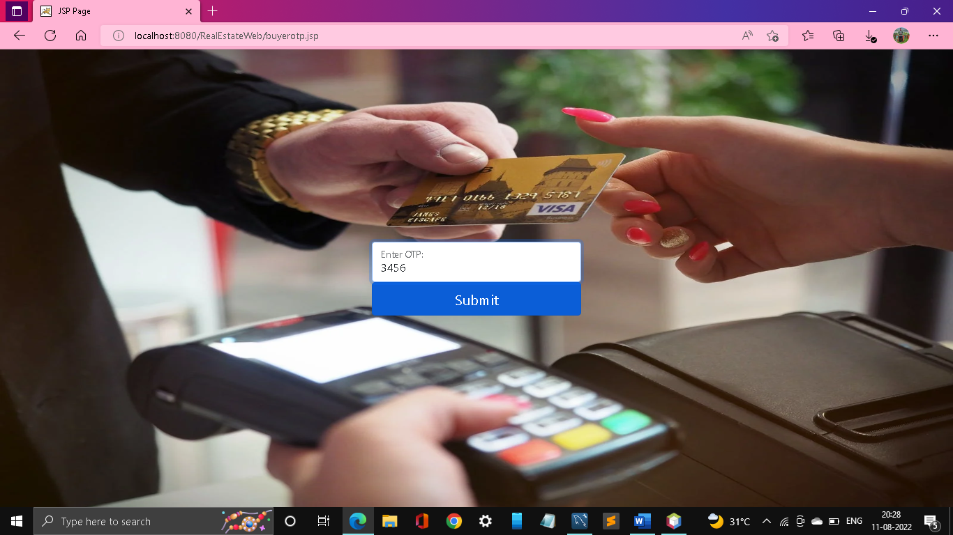

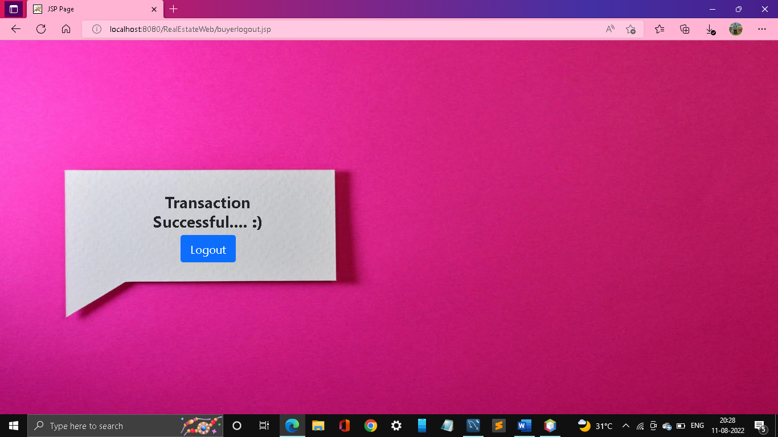

**Database screenshot:**

